­­­

**A**

**Project report**

**On**

**Online blood bank management system**

**­­­­­­­**

**CHRIST POLYTECHNIC INSTITUTE, RAJKOT**

DEPARTMENT: D.C.E.

**Developed By** **Guided By**

Joshi Jeet(196100307018) Prof. Arkesh Vora

Sara Varghese(196100307045)

**Christ Polytechnic Institute, Rajkot**



**CERTIFICATE**

This is to certify that **Mr. / Ms. JOSHI JEET KAUSHKIBHAI** From

**Christ Polytechnic Institute** College having Enrollment No: **196100307018**  has complete Semester VI Project Report Having title: **Online blood bank management system** in a group consisting of 2 persons under the guidance of the faculty guide **Prof. Arkesh Vora.______**

Institute Guide-UDP Head of Department

**Christ Polytechnic Institute**, **Rajkot.**



**CERTIFICATE**

This is to certify that **Mr. / Ms** **SARA SANJEEV VARGHESE** From

**Christ Polytechnic Institute** college having Enrollment No: **196100307045**  has complete Semester VI Project Report Having title: **Online blood bank management system** in a group consisting of 2 persons under the guidance of the faculty guide **Prof. Arkesh Vora.______**

Institute Guide-UDP Head of Department

**Candidate Declaration**

I declare that final semester report entitled **“ONLINE BLOOD BANK MANAGEMENT SYSTEM”** is my own work conducted under the supervision of the External/Internal guide **prof. Arkesh Vora** from **“Christ Polytechnic Institute”**.

I further declare that to the best of our knowledge the report for Diploma 6th semester does not contain part of the work which has been submitted for the award of Diploma Engineering either in this or any other university without proper citation.

Candidate’s Signature:___________________________

Candidate’s Name: **JOSHI JEET KAUSHIKBHAI**

Candidate’s Branch: Computer Engineering

Candidate’s Signature:___________________________

Candidate’s Name: **SARA SANJEEV VARGHESE**

Candidate’s Branch: Computer Engineering

**Prof. Arkesh Vora**

Project Guide,

Dept of Computer Engineering

Christ Polytechnic Institute,

Rajkot,

Gujarat.

**ACKNOWLEDGEMENT**

It is my pleasure to be indebted to various people, who directly or indirectly contributed in the development of this work and who influenced our thinking, behavior, and acts during the course of our training.

We express our unfathomable sense of pleasure towards **Mrs. Nymphea Goiga** principle of **Christ Polytechnic Institute** who gave us a chance to work. She frequently came to motivate and provide such an extraordinary infrastructure and resources to work in her premises.

We are also very thankful to our HODof Computer Department **Mrs. Payal Kapadiya** and all the faculty members who provided to be a constant motivation for the knowledge acquisition and the moral support throughout the whole project.

I express my sincere gratitude **Mr. Arkesh Vora,** worthy mentor, guide and a great teacher who influenced and inspired me in many ways.

Lastly, I would like to thank the almighty and my parents for their moral support and my friends with whom I shared our day-to-day experience and received lots of suggestions that improved our quality of work.

Jeet Joshi(196100307018)

Sara Varghese(196100307045)

**Abstract**

The purpose of Blood Bank Management System is to make the task of collecting blood easy and rapidly. Through this system, people who are in need of blood critically, can contact them and can get the blood quickly and free of charge. Everyone is welcome to register as a blood donor in camp.

Blood Bank Management System project makes it easy to give information regrading blood type, date of donation of blood, available blood group and many more. After the implementation of the project, the blood searching process is expected to be faster, easier, reliable. This project aims at maintaining all the information pertaining to blood donors, different blood groups available in each blood bank and help them manage in a better way.

**Introduction**

The **BLOOD BANK MANAGEMENT SYSTEM** is great project. This project is designed for successful completion of project on blood bank management system. The basic building aim is to provide blood donation service to the city recently. **Blood Bank Management System (BBMS)** is a browser based system that is designed to store, process, retrieve and analyze information concerned with the administrative and inventory management within a blood bank. This project aims at maintaining all the information pertaining to blood donors, different blood groups available in each blood bank and help them manage in a better way. Aim is to provide transparency in this field, make the process of obtaining blood from a blood bank hassle free and corruption free and make the system of blood bank management effective.

The Bloodbank system project report contain information related to blood like

* Blood type
* Date of Donation of blood
* validity of Bloods
* Available Blood group

**Problem Statement**

Users

Application has three kinds of users

1. Unregister users

2. Register users

3. Admin

Functionalities

Unregister users

1. He can view Index page containing introduction and elements of the application. (static page)

2. He/she can register by giving small piece of information.

Register users

1. He can view Index page containing introduction and elements of the application. (static page)

2. He can login to explore the features of website.

3. He can manage his account.

4. He can view the available objective question.

5. He can test his knowledge by attempting the test.

6. He can view his score after attempting the test.

7. He can logout from the website.

Admin

1. Admin can login.

2. Admin can manage test questions

3. Admin can logout.

|  |  |  |
| --- | --- | --- |
| **NO**  INDEX | **Description** | **Page number** |
| **1.** | Certificate  Candidate Declaration  Acknowledgements  Abstract  Introduction  Problem Statement | **02-08** |
| **2.** | **CHAPTER-1**  1.0 Introduction  1.1 Project summary  1.2 Project profile  1.3 Purpose  1.4 Scope  1.5 Technology used | **11-13** |
| **3.** | **CHAPTER-2**  2.0 System Requirement Study  2.1 User and administrator characteristics  2.2 Software and hardware requirement | **14-15** |
| **4.** | **CHAPTER-3**  3.0 System Analysis  3.1 Study of current system­  3.2 Demerits of the current system  3.3 Requirement of new system  3.4 Feasibility study | **16-17** |
| **5.** | **CHAPTER-4**  Data Dictionary  4.0 Screenshots  4.1 Database of online Blood Bank Management System  4.2 User Table  4.3 Donor Registration/Login Table  4.4 Donation Table  4.5 Request Table  4.6 Contact Us Table  4.7 Camp Table  4.8 Blood Group Table  4.9 City Table  4.10 Gallary Table  4.11 News Table  4.12 State Table  4.13 Advertisement | **18-21** |
| **6.** | **CHAPTER-5**  Diagrams  5.0 Data flow diagram  5.0.1 DFD Diagram Level Zero  5.0.2 DFD Diagram Level 1st For Admin  5.0.3 DFD Diagram Level 1st For Donor  5.0.4 DFD Diagram Level 1st For Requester  5.1 Entity Relationship diagram  5.2 Use Case Diagram  5.2.1 Use Case Diagram For Donor  5.2.2 Use Case Diagram For Requeste  5.2.3 Use Case Diagram For Admin  5.3 Class Diagram  5.4 Activity Diagram  5.4.1 Activity Diagram For Admin  5.4.2 Activity Diagram For Donor  5.4.3 Activity Diagram For Requester | **22-34** |
| **7.** | **CHAPTER-6**  User Manual  6.0 User Manual | **35-58** |
| **8.** | **CHAPTER-7**  7.0 Pros | **59-60** |
| **9.** | **CHAPTER-8**  8.0 Limitation & future enhancement  8.1 Limitation  8.2 Future Enhancement | **61-62** |
| **10.** | **CHAPTER-9**  Bibliography | **63-64** |

**INDEX OF DATA DICTIONARY**

|  |  |  |
| --- | --- | --- |
| **NO** | **Description** | **Page Number** |
| 1 | Database of online Blood Bank Management System | 21 |
| 2 | User Table | 21 |
| 3 | Donor Registration/Login Table | 21 |
| 4 | Donation Table | 22 |
| 5 | Request Table | 22 |
| 6 | Contact Us Table | 22 |
| 7 | Camp Table | 22 |
| 8 | Blood Group Table | 23 |
| 9 | City Table | 23 |
| 10 | Gallary Table | 23 |
| 11 | News Table | 23 |
| 12 | State Table | 23 |
| 13 | Advertisement | 23 |
|  |  |  |
|  |  |  |

**INDEX OF USER MANUAL**

|  |  |  |
| --- | --- | --- |
| **NO** | **Description** | **Page Number** |
| 1 | Home Page | 39 |
| 2 | Donor Registration | 40 |
| 3 | Send Request | 40 |
| 4 | View Request | 41 |
| 5 | Camp | 42 |
| 6 | Login | 43 |
| 7 | Search | 43 |
| 8 | Contact Us | 44 |
| 9 | About Us | 45 |
| 10 | Admin Login | 46 |
| 11 | Admin Panel | 46 |
| 12 | Add User | 47 |
| 13 | Update User | 47 |
| 14 | Delete User | 48 |
| 15 | Add City | 48 |
| 16 | Update City | 49 |
| 17 | Delete City | 49 |
| 18 | Add State | 50 |
| 19 | Update State | 50 |
| 20 | Delete State | 51 |
| 21 | Add Camp | 51 |
| 22 | Delete Camp | 52 |
| 23 | Update Camp | 52 |
| 24 | Add Blood Group | 53 |
| 25 | Update Blood Group | 53 |
| 26 | Delete Blood Group | 54 |
| 27 | Add Gallery | 54 |
| 28 | Delete Gallery | 55 |
| 29 | Add News | 55 |
| 30 | Delete News | 56 |
| 31 | Add Advertisement | 56 |
| 32 | Delete Advertisement | 57 |
| 33 | View City | 57 |
| 34 | View State | 58 |
| 35 | View Advertisement | 58 |
| 36 | View News | 59 |
| 37 | View Blood Group | 59 |
| 38 | View Camp | 60 |
| 39 | Donor Panel | 60 |
| 40 | View Donation | 61 |
| 41 | Blood Donation | 61 |
| 42 | Update Profile | 62 |
| 43 | Change Password | 62 |

**CHAPTER-1**

**Introduction**

**1.0 Introduction**

* 1. **Project summary:**

The main objective of the Blood Bank Management System is to manage the details of Blood, Donor, Blood Group, Blood Bank, Stock…. The purpose of the project is to build an application program to reduce the manual work for managing the Blood, Donor , Blood Cell, Blood group.

**1.2 Project Profile:**

Front End : PHP, CSS (Bootstrap Framework), Html 5

Back End : MySQL

Documentation tools : Microsoft Office

Project duration : 4 Months

Project Guide : Arkesh Vora

Institute Name : Christ Polytechnic Institute, Rajkot

* 1. **Purpose:**

Main purpose of this application is to provide such facility to the students to enhance their programming skills.

The main objective of project is for candidate to appear for an online test in an effective way and there is no loss of time to check the paper.

* 1. **Scope:**

Every application development project should begin with an analysis of the requirement and clear list of the goals.

The problem is broken into successively manageable parts for individual study.

The basic aim of analysis is to obtain a clear understanding of user’s need and exactly is desired from the requirement of required information for our practice training. We ride my best for the practical study and presentation of this project.

* 1. **Technology used:**

The languages we have used to accomplish our project are Programming Language PHP & MySQL database.

**HTML:**

HTML is a language for structuring and presenting content for the World Wide Web, a core technology of the Internet. It is the fifth revision of the HTML standard its only provide new feature for design page.

**Limitation:**

¬ Not provide Dynamic page generation

¬ Cross browser support not available

**JavaScript:**

JavaScript is a scripting language. JavaScript was designed to add interactivity to HTML pages. JavaScript is to add additional interaction between the website and its visitors with just a little extra work by the web developer. JavaScript is a client-side scripting language. This means the web surfer's browser will be running the script.

**CSS:**

Cascading Style Sheets (CSS) is a style sheet language used for describing the presentation semantics (the look and formatting) of a document written in a markup language. Its most common application is to style web pages written in HTML.

**PHP:**

PHP is a server-side scripting language designed for web development but also used as a general purpose programming language. PHP originally stood for Personal Home Page. PHP processor module, which generates the resulting web page: PHP commands can be embedded directly into an HTML source document rather than calling an external file to process data. The PHP language was originally implemented as an interpreter, and this is still the most popular implementation.

**XAMP-Server:**

A Stack of programs that are designed to run HTTP server which understand PHP.

• Windows - The Operating System

• Apache - HTTP Server

• MySQL - A database server and client

• PHP - A plug-in for Apache so it can run (interpret) PHP Scripts.

**My-SQL:**

My-SQL, the most popular Open Source SQL database management system, is developed, distributed, and supported by Oracle Corporation. My-SQL is a database management system. A database is a structured collection of data. The My-SQL Database Server is very fast, reliable, scalable, and easy to use. If that is what you are looking for, you should give it a try. My-SQL Server can run comfortably on a desktop or laptop, alongside your other applications, web servers, and so on, requiring little or no attention.

My-SQL Server works in client/server or embedded systems. The My-SQL Database Software is a client/server system that consists of a multi-threaded SQL server that supports different backbends, several different client programs and libraries, administrative tools, and a wide range of application programming interfaces (APIs).

**CHAPTER-2**

**System Requirement Study**

**2.0 System Requirement Study**

It studies the current business system to find out how it work and where improvement should be made? This study considered both manually and computer method.

Requirement is a feature that must be include in new system it may be include a way capturing or processing data, producing information.

**2.1 User and administrator characteristics**

User Characteristics

• User characteristics can donate the blood in different camp.

• requester can send the request for blood any city or state.

Administrator Characteristics

• Administrator can manage all the function like add city, delete city, update city, add blood, delete blood, update blood different type of function manage the admin.

• He/she will be safely responsible for maintaining of all function.

**2.2 Software and Hardware Requirement**

Software Requirement

1. Front End : PHP

2. Back End : My-SQL

Hardware Requirement

Processor : Celeron 500 MHZ Or Any Pentium Processor Or Above

Ram : 64mb Or Above

HDD : Minimum Requirement Is 1.2 GB

Display : Standard VGA Or SVGA Card

**CHAPTER-3**

**System Analysis**

**3.0 System Analysis**

A system analysis is responsible for researching, planning, and recommending software and system choices to meet an organizations business requirement.

System analysis may act as liaisons between vendors and the organization they represent. They may be responsible for developing cost analysis, design consideration, and implementation timelines. They may also be responsible for feasibility studies of a computer system before making recommendation to senior management.

Basically a system analyst performs the following tasks:

1. Interact with students to know their requirements.

2. Interact with designers to convey the possible interface of the software.

3. Interact the users to keep track of system development.

4. Perform system testing with live data with the help of testers.

5. Successfully implement the new system.

**3.1 Study of Current System:**

Current Auction System is fully manual. Administrator is managing all documents papers. They are having problem in retrieving all data like current price, time remaining for product etc.

**3.2 Demerits of Current System:**

According to the system there are many obstacles for students to enhance their knowledge.

**3.3 Requirement of the New System:**

It is necessary to automatic management of the system of such management system by using automatic & computerized system of management it is easy for administrator to manage records related to materials user details etc.

**3.4 Feasibility Study:**

The feasibility study is performed to determine whether the proposed system is viable considering the Technical, Operational and Economical factors. After going through feasibility study we can have a clear-cut view of the system’s benefits and drawbacks.

**Technical Feasibility:**

The proposed system is developed using Active Server Page, VB Script and HTML as front-end tool and Oracle 8 as the back end. The proposed system needs a Personal Web Server to serve the requests submitted by the users. The Web browser is used to view the web page that is available within the Windows operating system itself. The proposed system will run under Win9x, NT, and win2000 environment. As Windows is very user friendly and GUI OS it is very easy to use. All the required hardware and software are readily available in the market. Hence the system is technically feasible.

**Operational Feasibility:**

The proposed system is operationally feasible because of the following reasons.

The customer is benefited more as most of his time is saved. The customer is serviced at his place of work.

The cost of the proposed system is almost negligible when compared to the benefits gained.

**Economical Feasibility:**

As the necessary hardware and software are available in the market at a low cost, the initial investment is the only cost incurred and does not need any further enhancements. Hence it is economically feasible. The system is feasible in all respects and hence it encourages taking up the system design.

**Gathering Information:**

The analysis through collection of data plays the wider role in the analysis of the system. So the data is collected at different levels of management to keep track of full information of the system.

The collection of data is done from

Top Level Management

Middle Level Management

Low Level Management

**CHAPTER-4**

**Data Dictionary**

**4.0 Screen Shot**

**4.1 Database of online Blood Bank Management System**

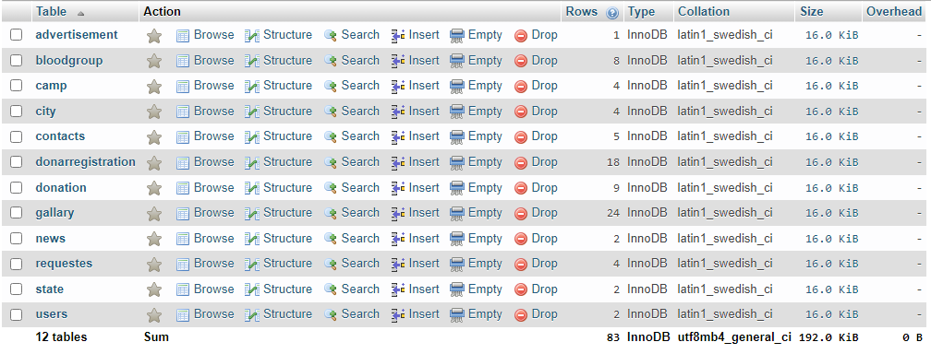

**4.2 User Table**

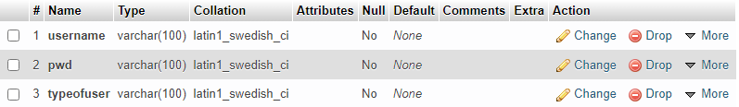

**4.3 Donor Registration/Login Table**

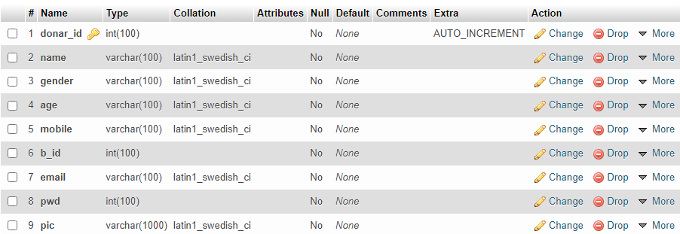

**4.4 Donation Table**

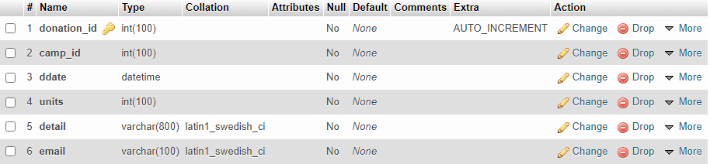

**4.5 Request Table**

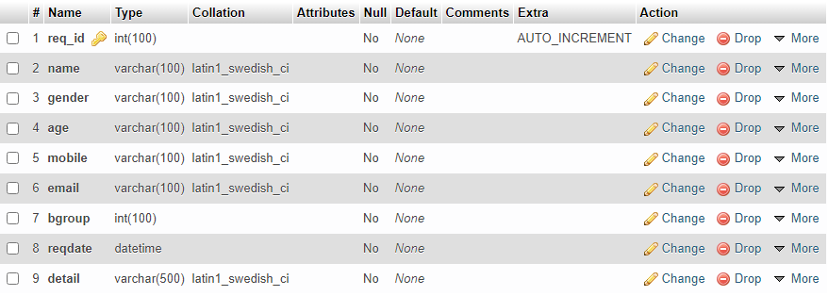

**4.6 Contact Us Table**

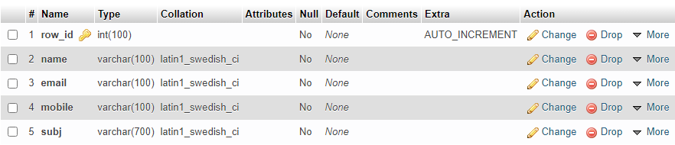

**4.7 Camp Table**

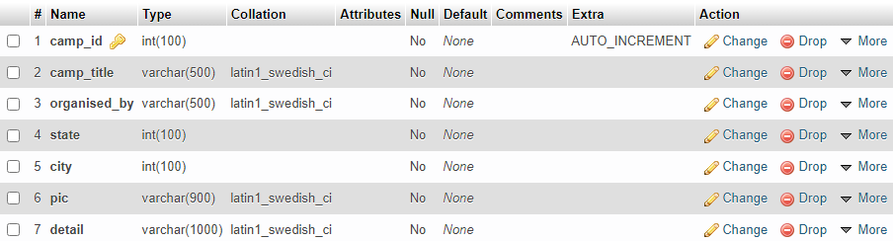

**4.8 Blood Group Table**

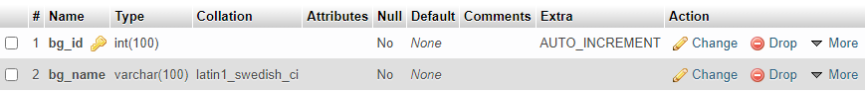

**4.9 City Table**

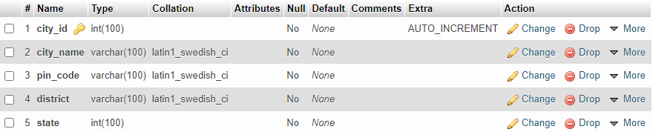

**4.10 Gallary Table**

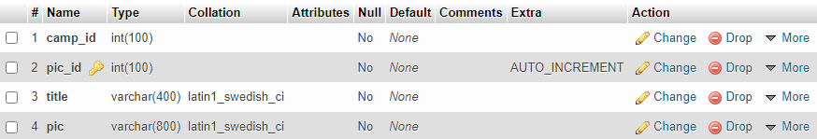

**4.11 News Table**

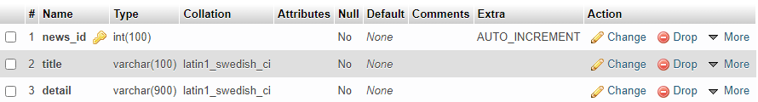

**4.12 State Table**

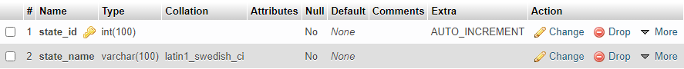

**4.13 Advertisement Table**

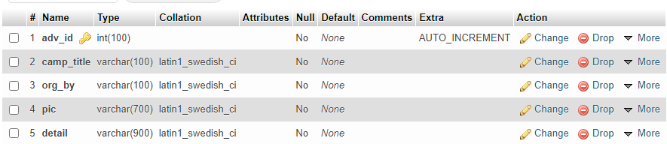

**CHAPTER-5**

**Diagrams**

**5.0** **Data flow Diagram**

**5.0.1 DFD Diagram Level Zero**

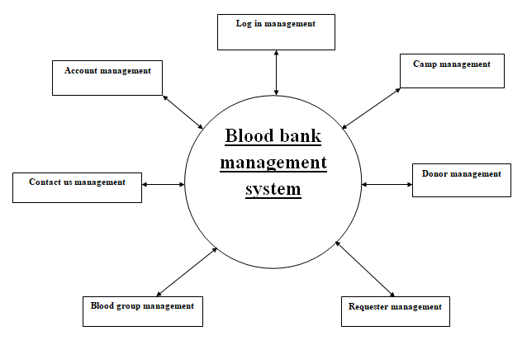

**5.0.2 DFD Diagram Level 1st For Admin**

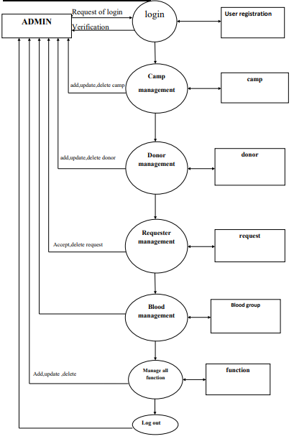

**5.0.3 DFD Diagram Level 1st For Donor**

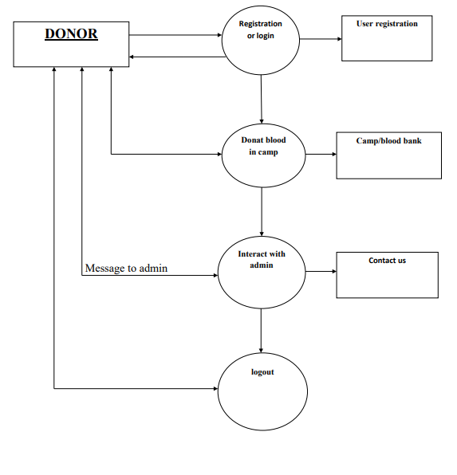

**5.0.4 DFD Diagram Level 1st For Requester**

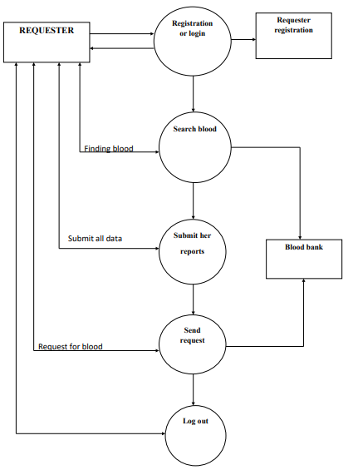

**5.1 Entity Relationship Diagram**

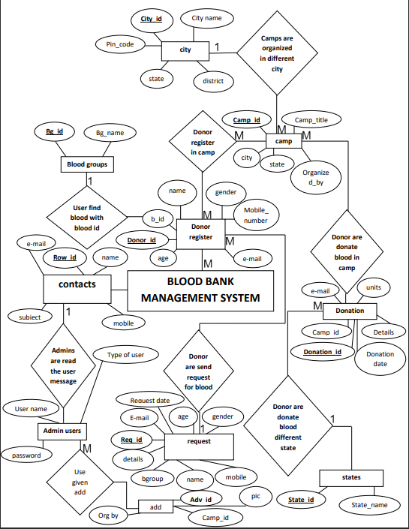

**5.2 Use Case Diagram**

**5.2.1 Use Case Diagram for Donor**

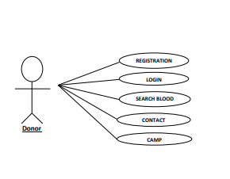

**5.2.2 Use Case Diagram For Requester**

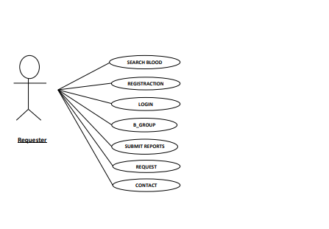

**5.2.3 Use Case Diagram For Admin**

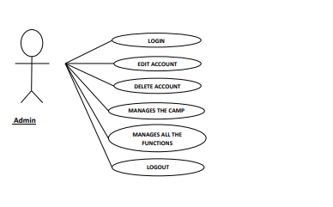

**5.3. Class Diagram**

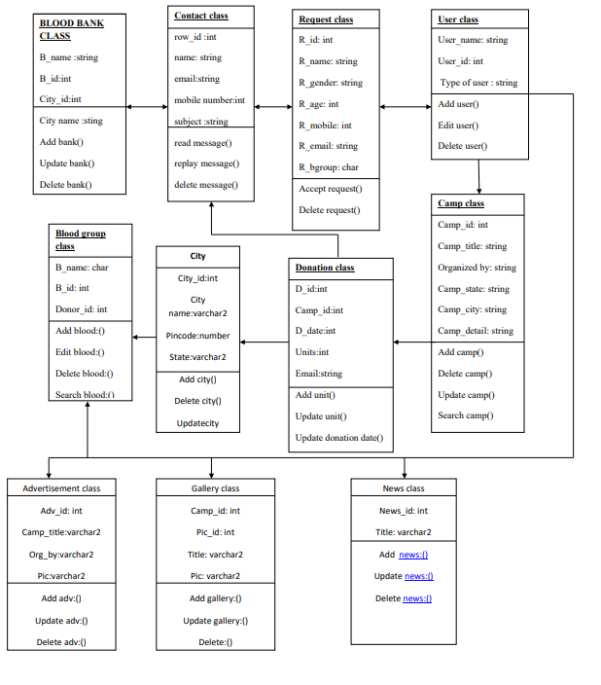

**5.4 Activity Diagram**

**5.4.1 Activity Diagram For Admin**

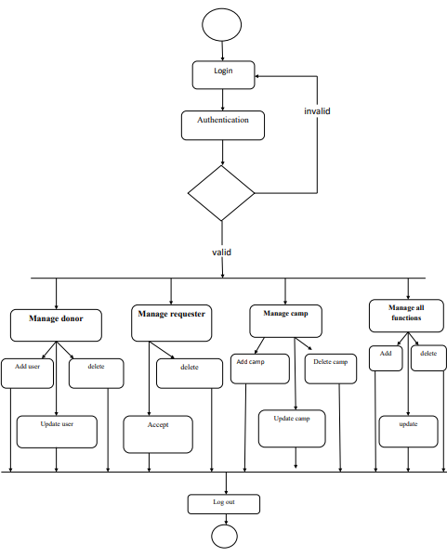

**5.4.2 Activity Diagram For Donor**

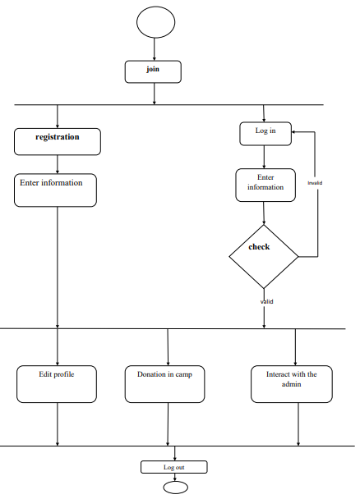

**5.4.3 Activity Diagram For Requester**

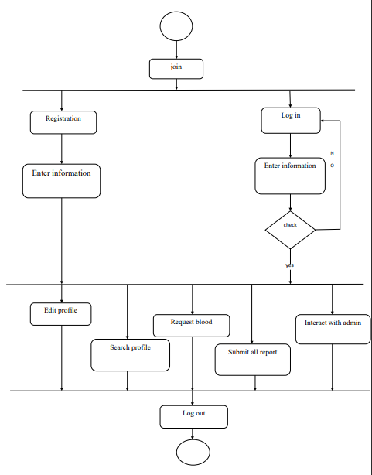

**CHAPTER-6**

**User Manual**

**6.0 USER MANUAL**

**6.1 Home Page**

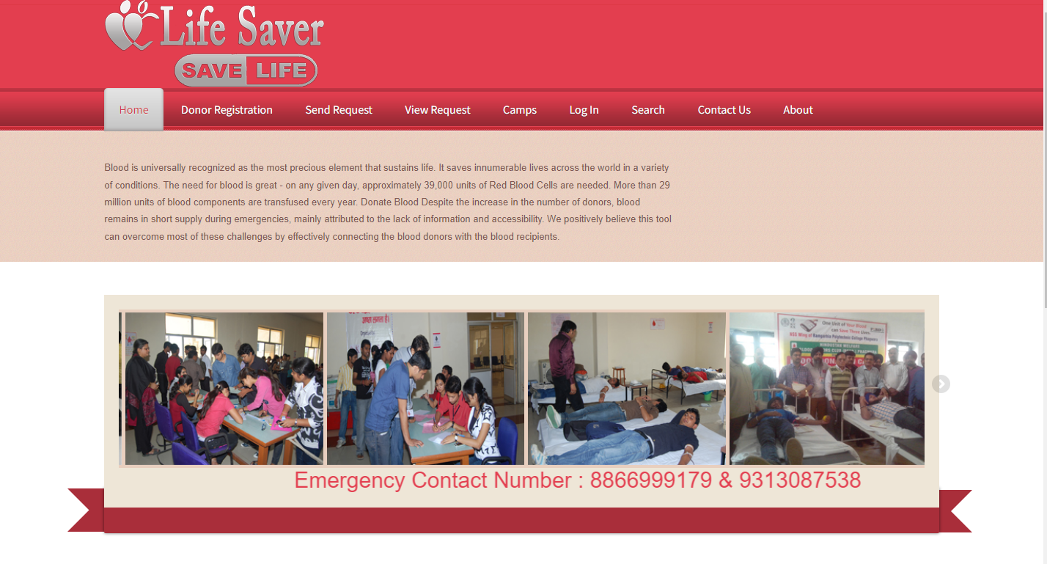

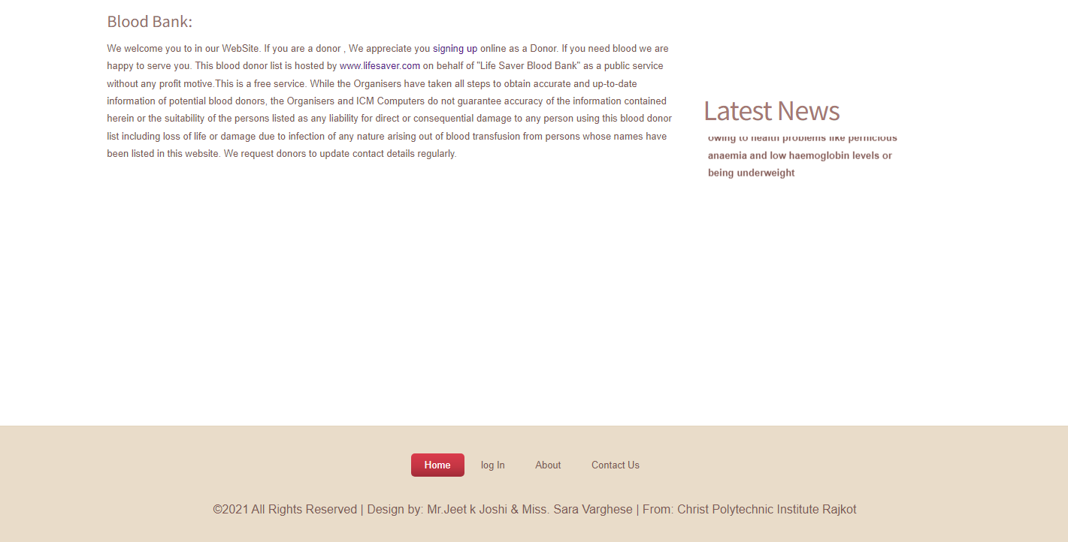

**Home**

This is our home page. Our home page includes navigation bar that contains items like Home, Donor Registration, Send Request, View Request, Camps, and Log in for user, Search, Contact Us, About Us. Clicking on each navigation menu item will redirect you to their respected page that contains more information.

**6.2 Donor Registration**

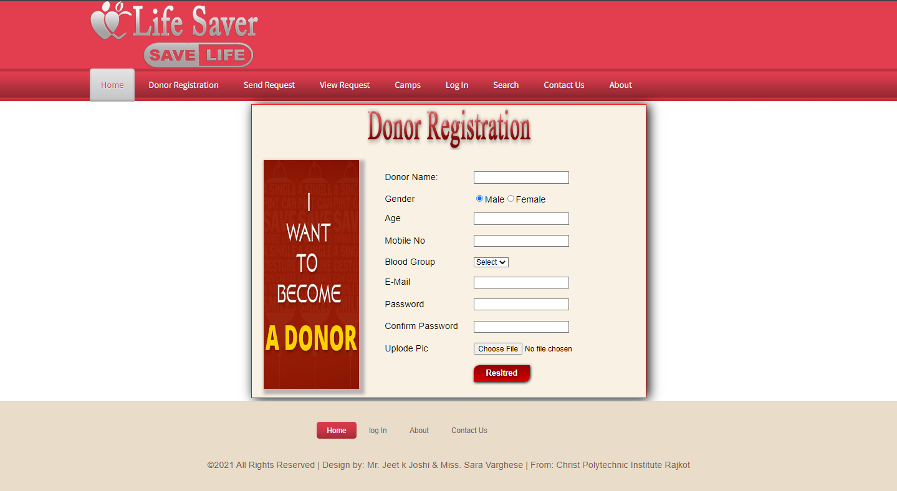

**Donor Registration**

New visitors must come on this page to register themselves. For users to login or do donating of blood users have to first register.

**6.3 Send Request**

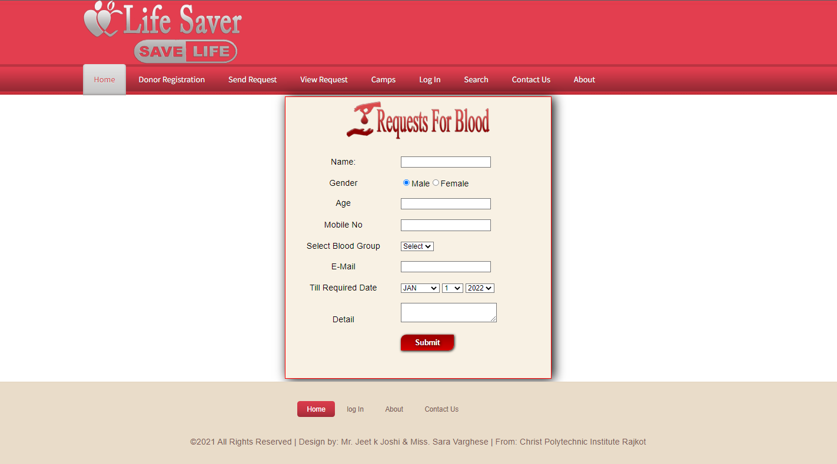

**Send Request**

If any users want to request blood then they have to come to this page which is Send Request. Here users will have to submit the information regarding their request for blood like: Name, Blood Group, Required Date etc.

**6.4 View Request**

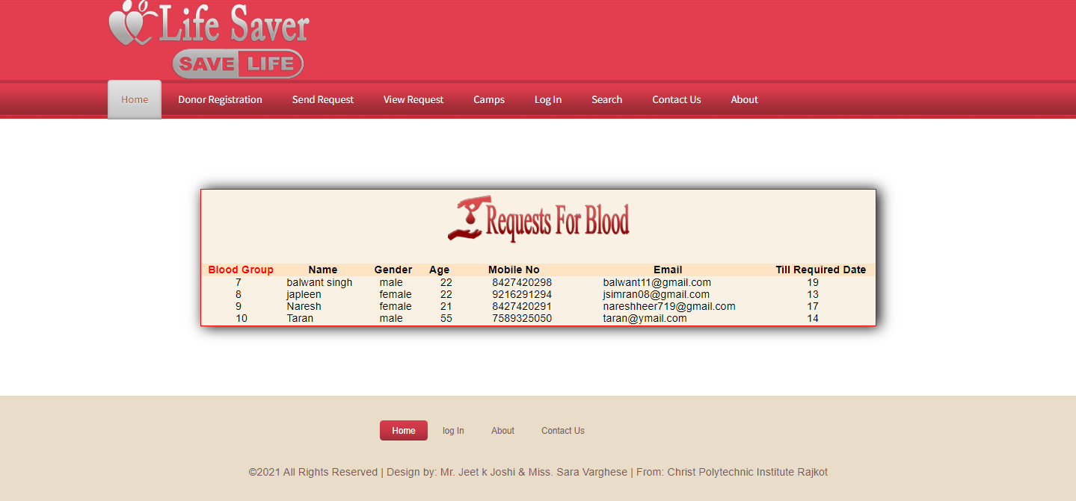

**View Request:**

This page shows the entire request for blood that users have asked.

**6.5 Camp**

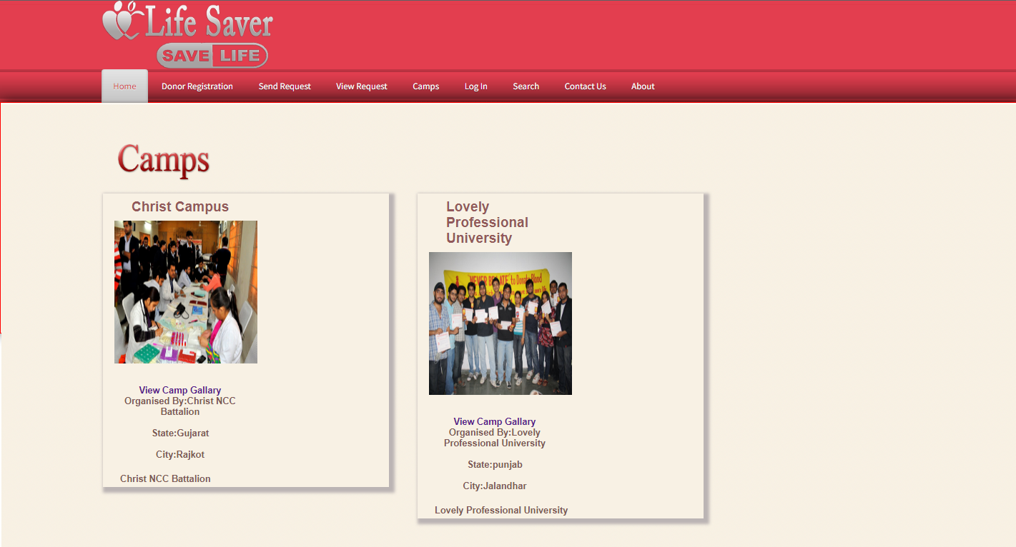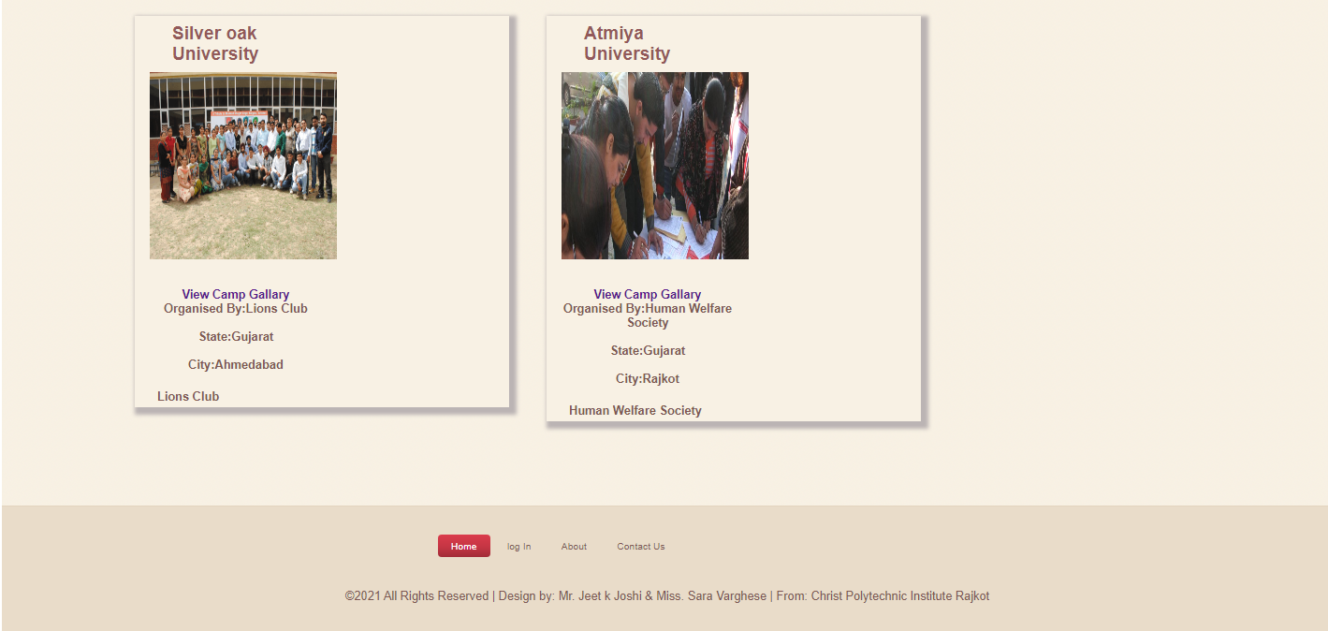

**Camps**

In this page users can view different camps that were held on different location. Users can view photos of camps etc.

**6.6 Login**

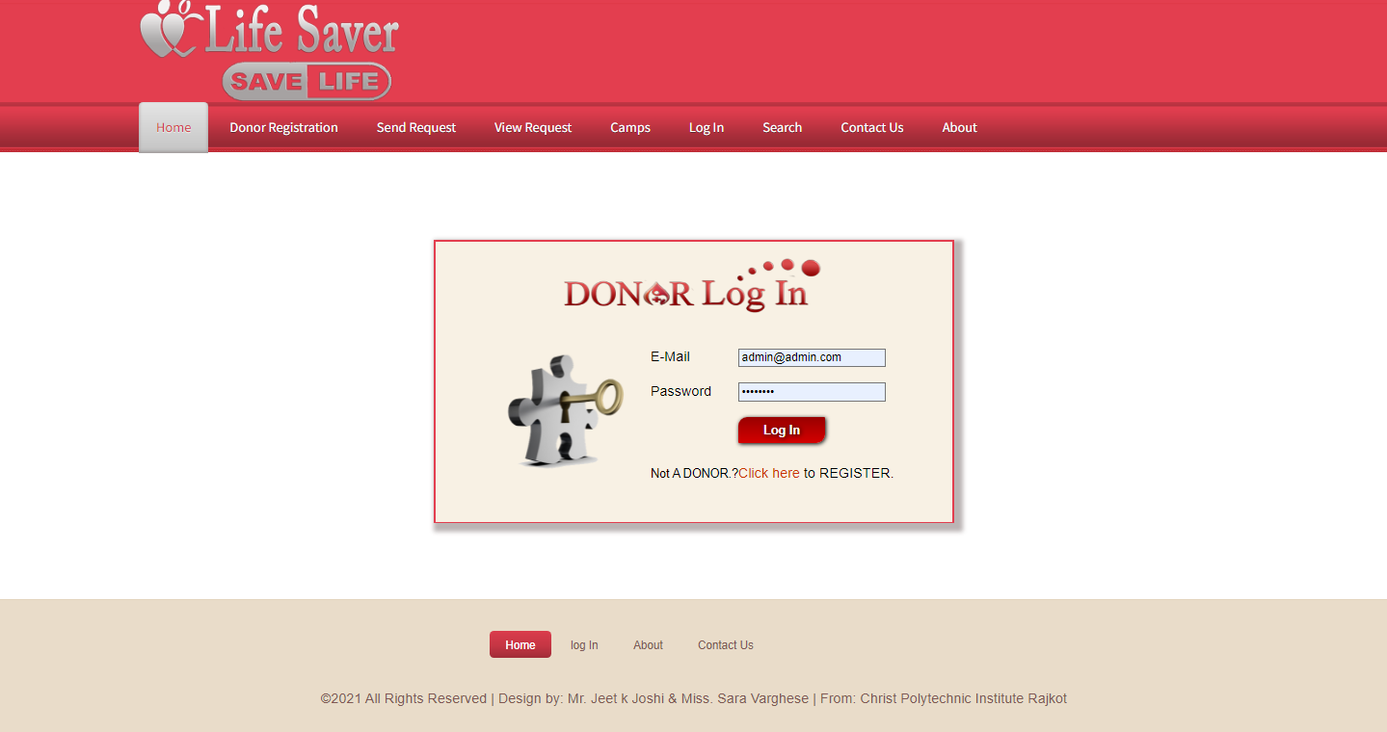

**Log In**

After logging in to this page user can view the request for the blood, donation of blood, User can update their profile details, User can change their password etc.

**6.7 Search**

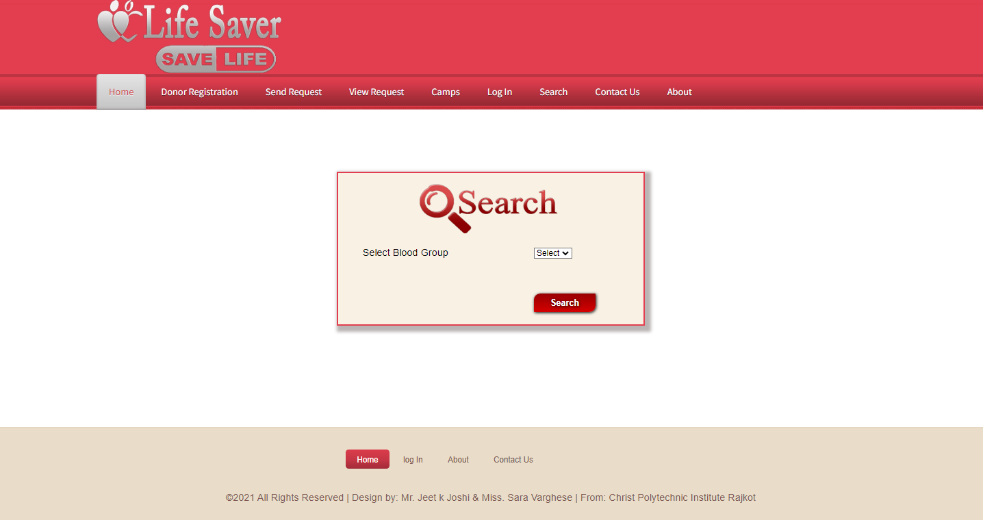

**Search**

In Search page, user can search for the different kind of bloods based on the Blood Group.

**6.8 Contact Us**

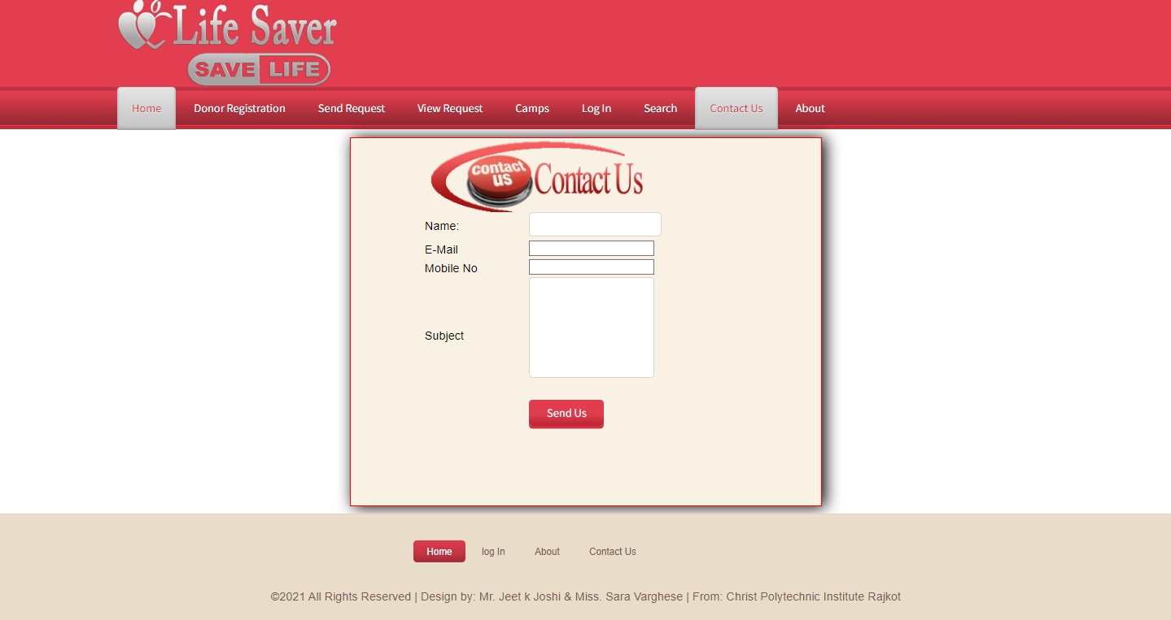

**Contact Us**

Users can get in touch with us through Contact Us page.

**6.9 About Us**

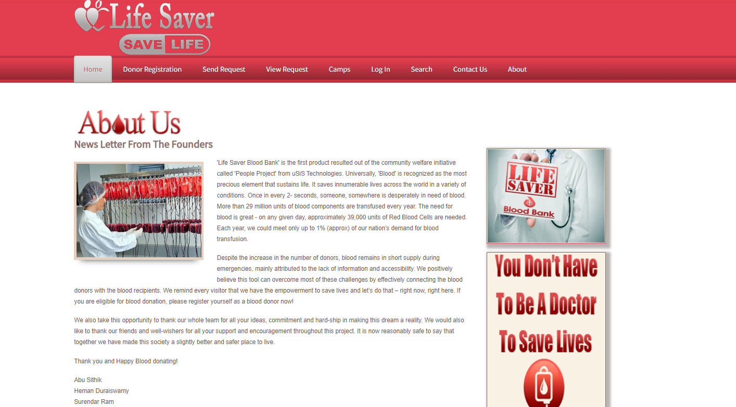

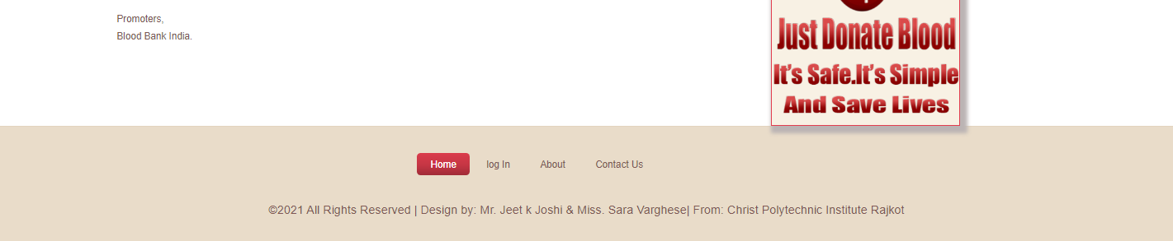

**About Us**

This page shows details about this website.

**6.10 Admin Login**

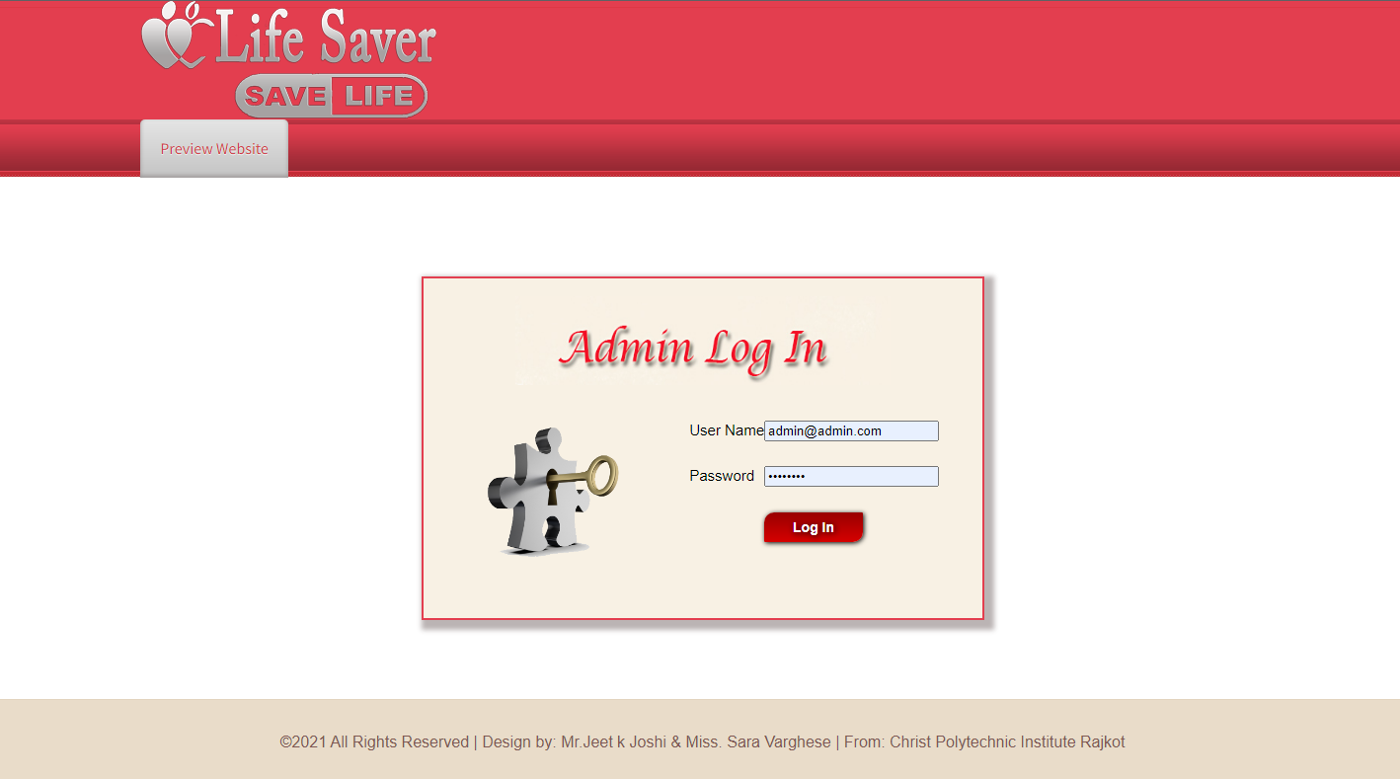

**Admin Login**

Admin are Login in admin panel using admin User Name & Password.

**6.11 Admin Panel**

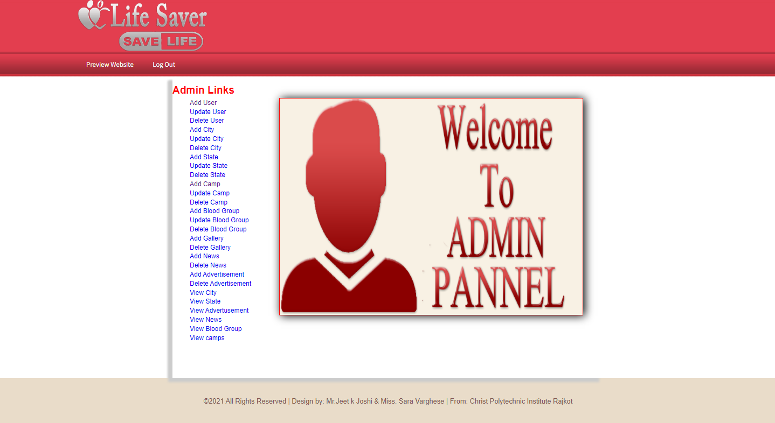

**Admin Panel**

Admin Panel has full control over the website. Admin panel can only be accessible by Admin. Admin can perform various things like: Add User, Add Blood Group, Delete User etc.

**6.12 Add User**

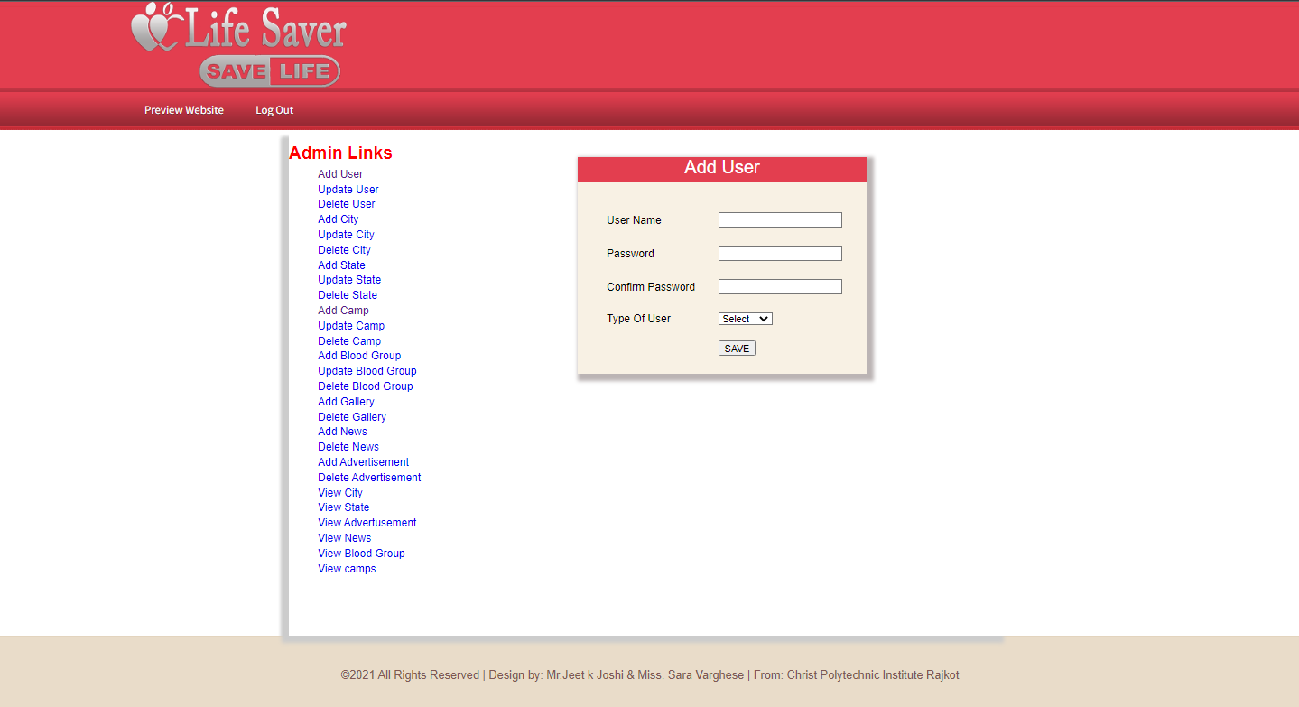

**Add user**

Add user provides the functionality to add a new user which can interact with our web site.

**6.13 Update User**

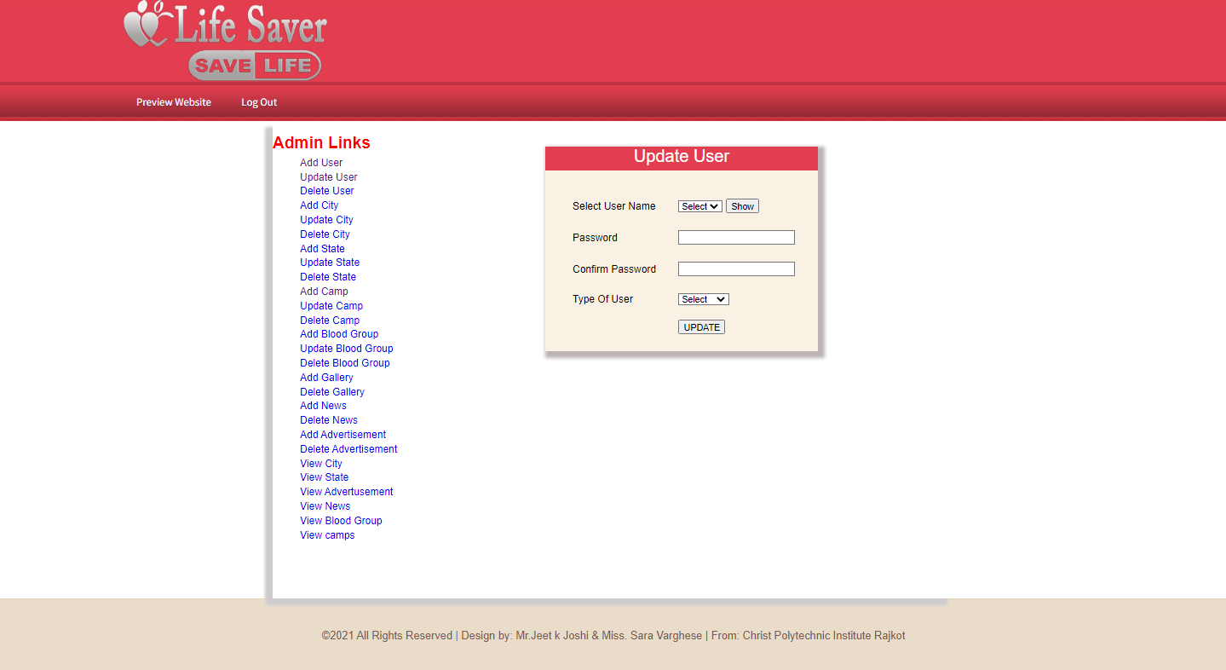

**Update user**

This link button helps admin to switch user from admin to user and vice versa.

**6.14 Delete User**

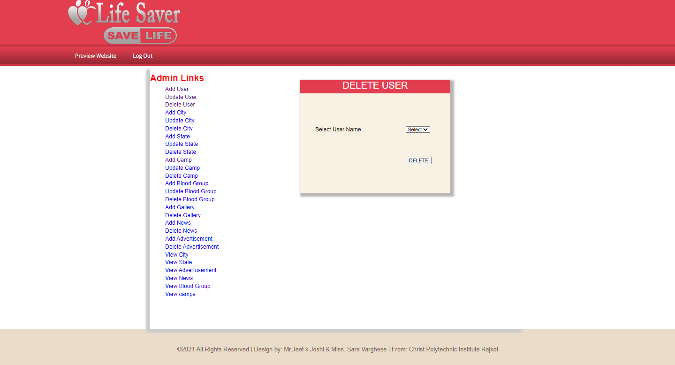

**Delete user**

Admin can delete existing user which can admin or a normal user.

**6.15 Add City**

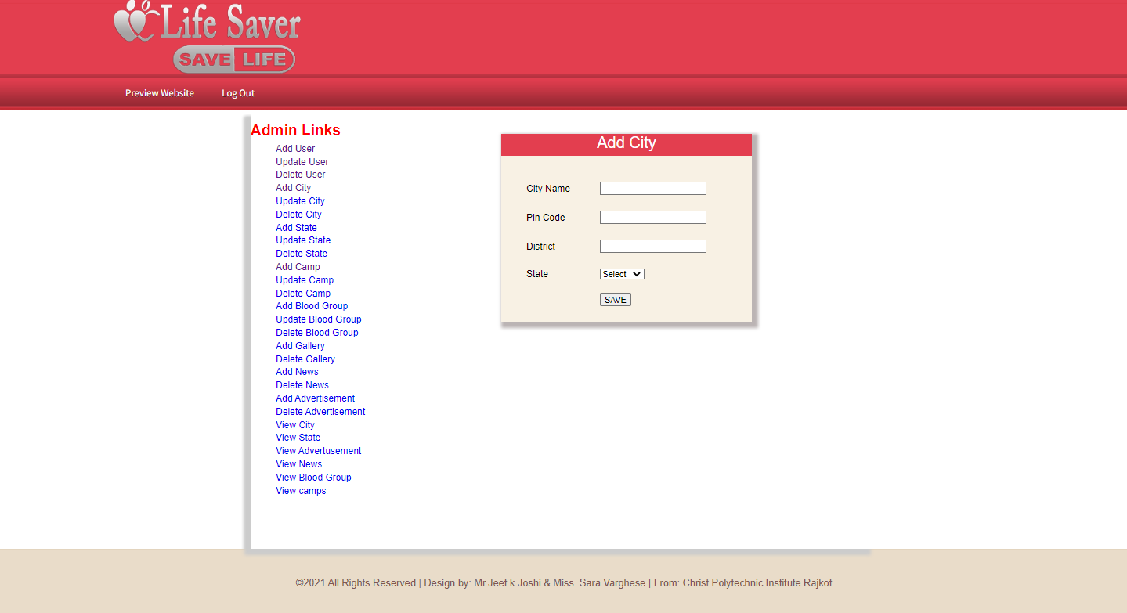

**Add City**

A new city will be added to the database for those cities where we aren’t active.

**6.16 Update City**

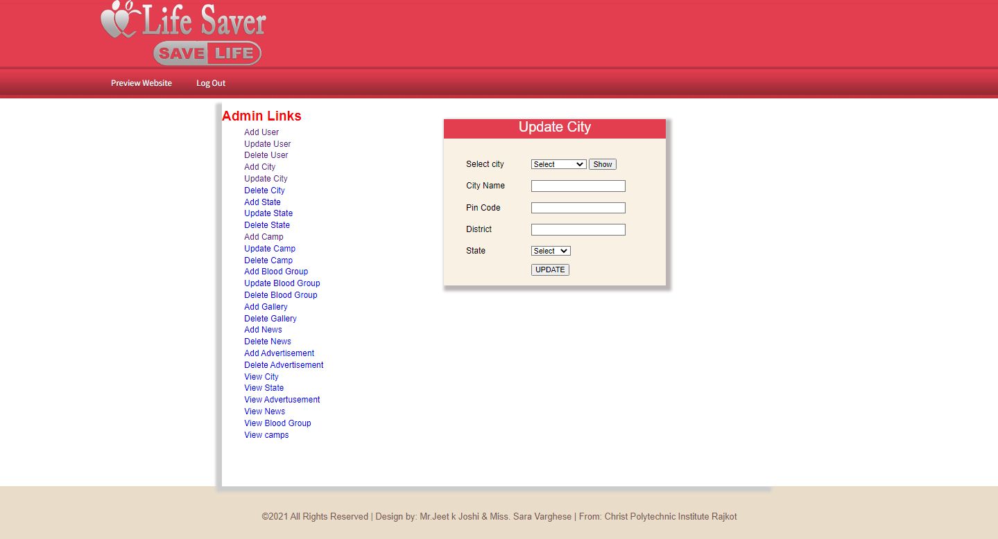

**Update City**

With help of this link button we can update the fields of our active city.

**6.17 Delete City**

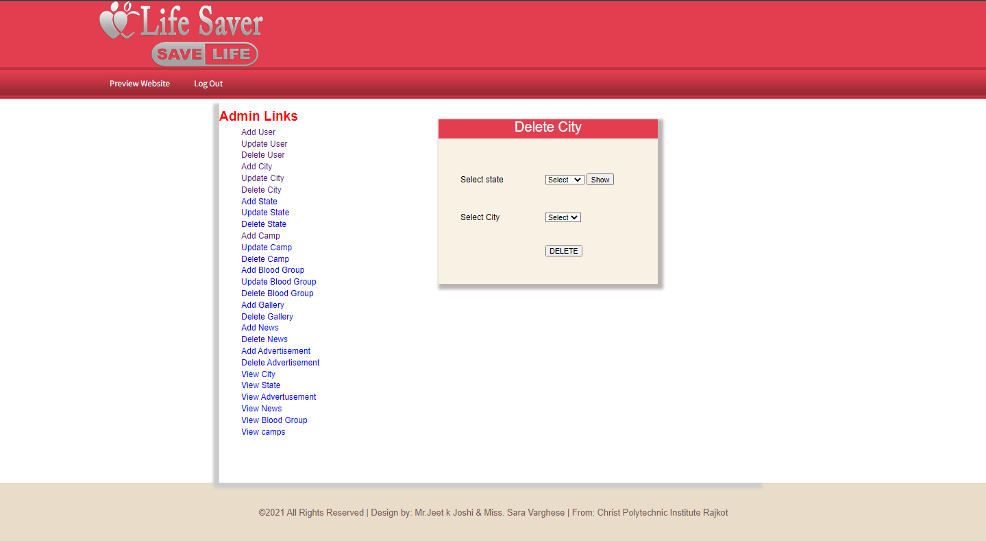

**Delete City**

With help of this hyper link we can delete the existing city.

**6.18 Add State**

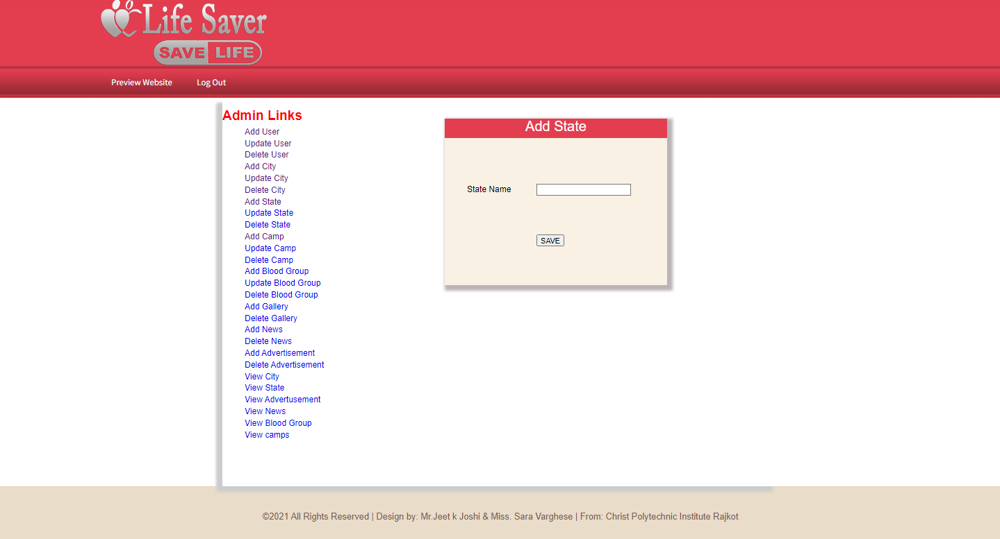

**Add State**

A new state will be added to the database for those states where we aren’t active.

**6.19 Update State**

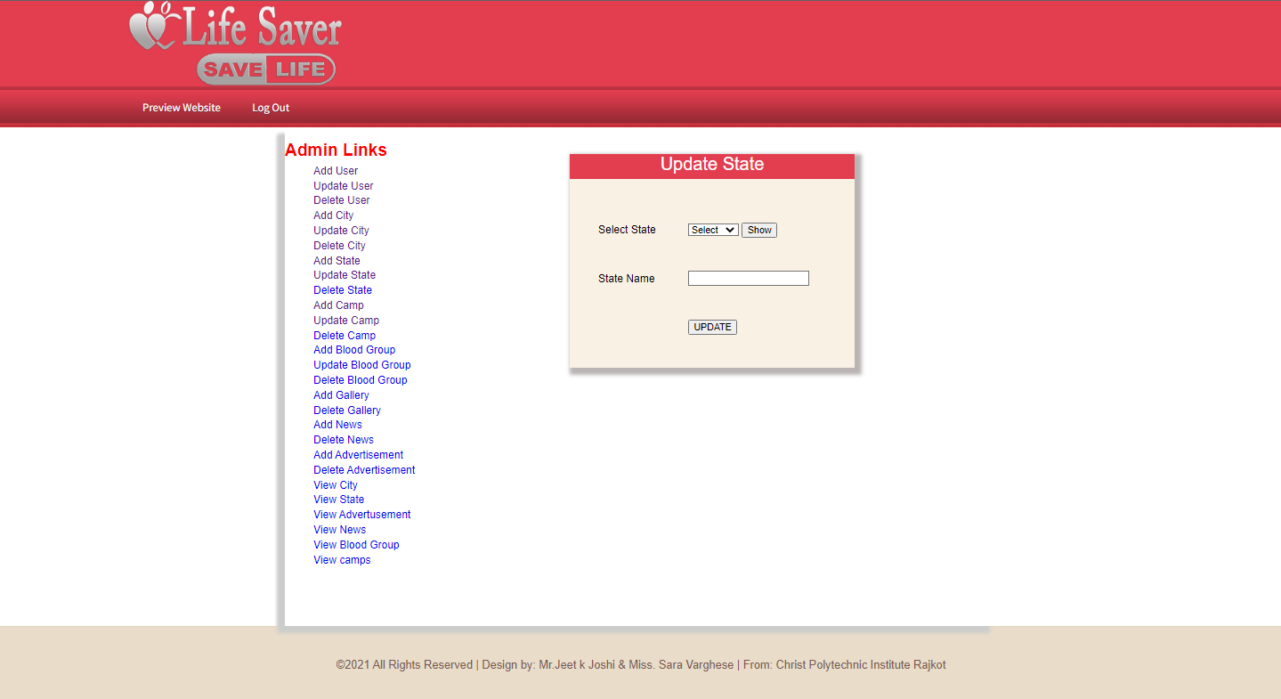

**Update State**

With help of this hyper link we can update the fields of our active state.

**6.20 Delete State**

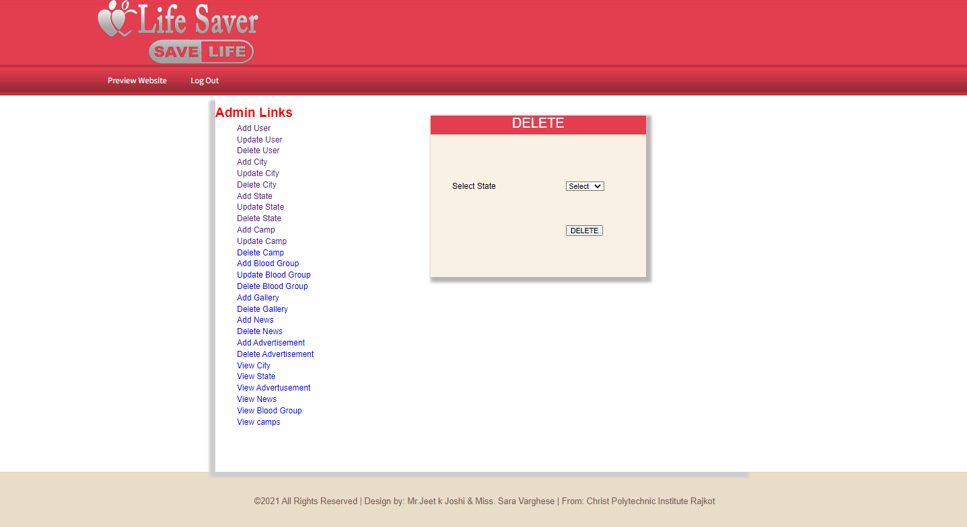

**Delete State**

With help of this hyper link we can delete the existing state.

**6.21 Add Camp**

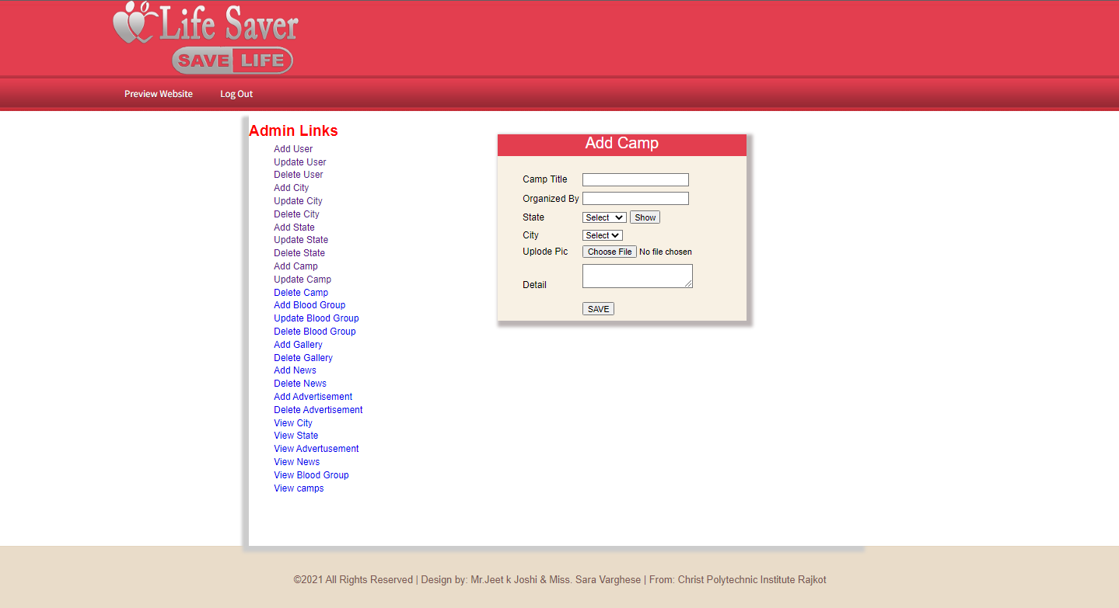

**Add Camp**

A new camp will be added to the database for those camps where we aren’t active.

**6.22 Delete Camp**

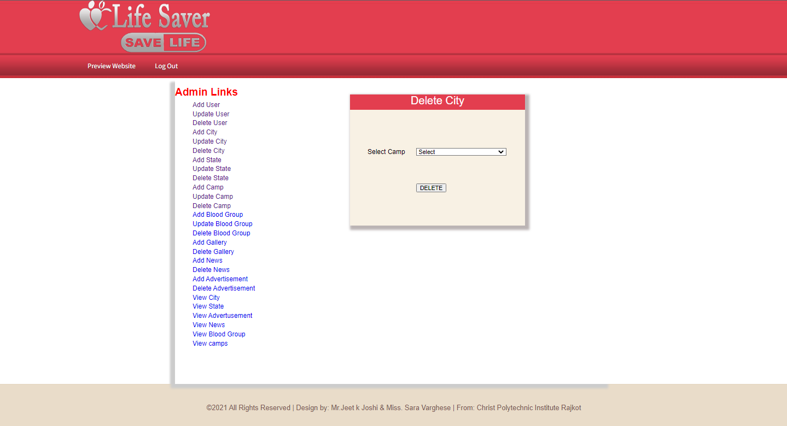

**Delete Camp**

With help of this hyper link we can delete the existing camp.

**6.23 Update Camp**

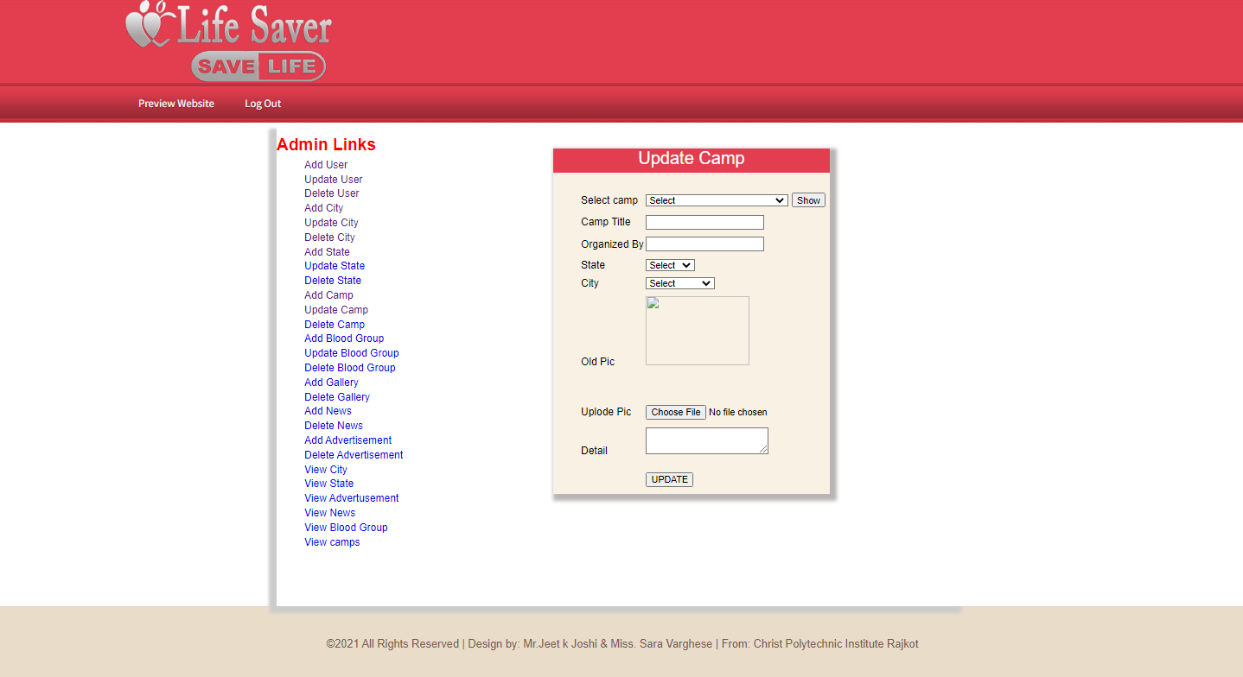

**Update Camp**

With help of this hyper link we can update the fields of our active camp.

**6.24 Add Blood Group**

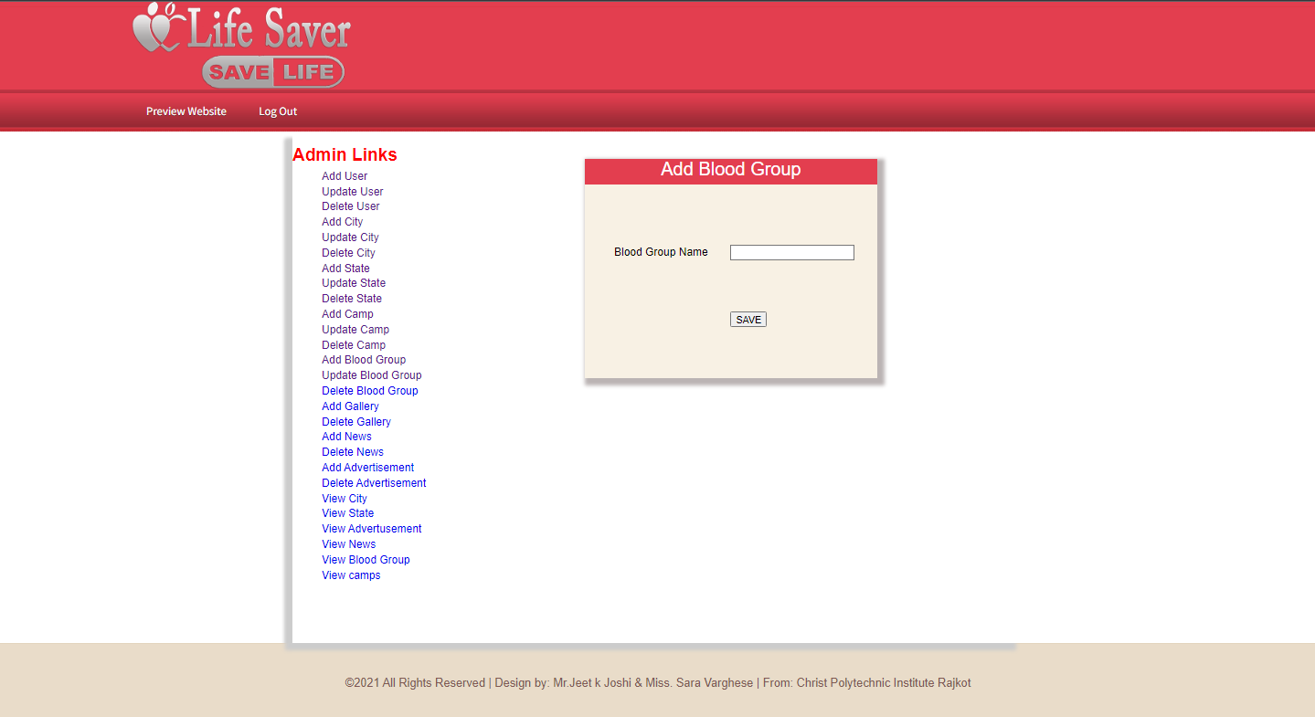

**Add Blood Group**

A new blood group will be added to the database for those group where we aren’t active.

**6.25 Update Blood Group**

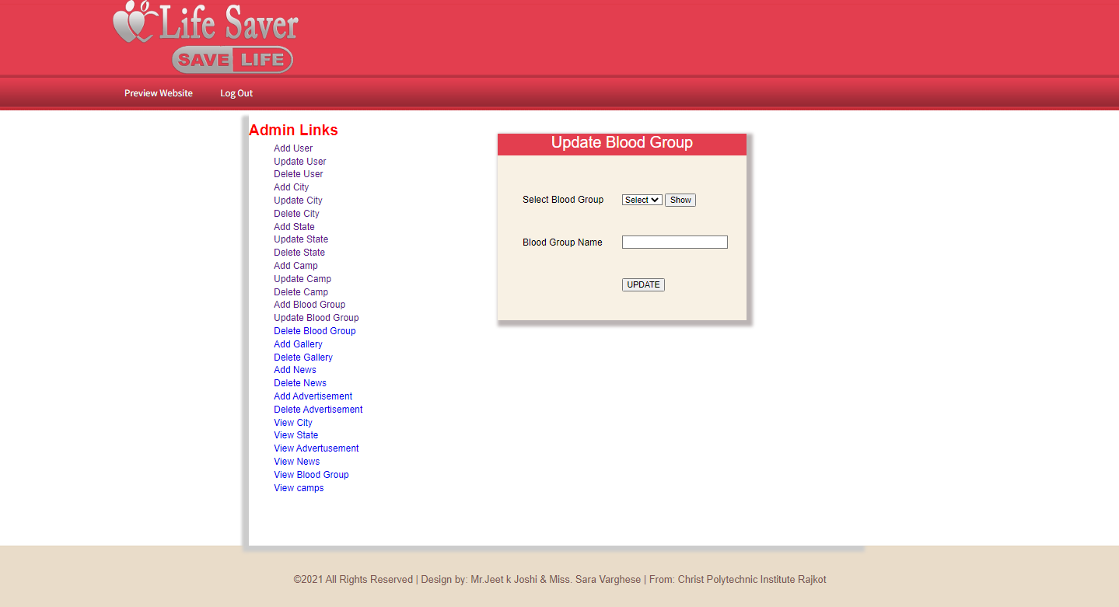

**Update Blood Group**

With help of this hyper link we can update the fields of our active blood group.

**6.26 Delete Blood Group**

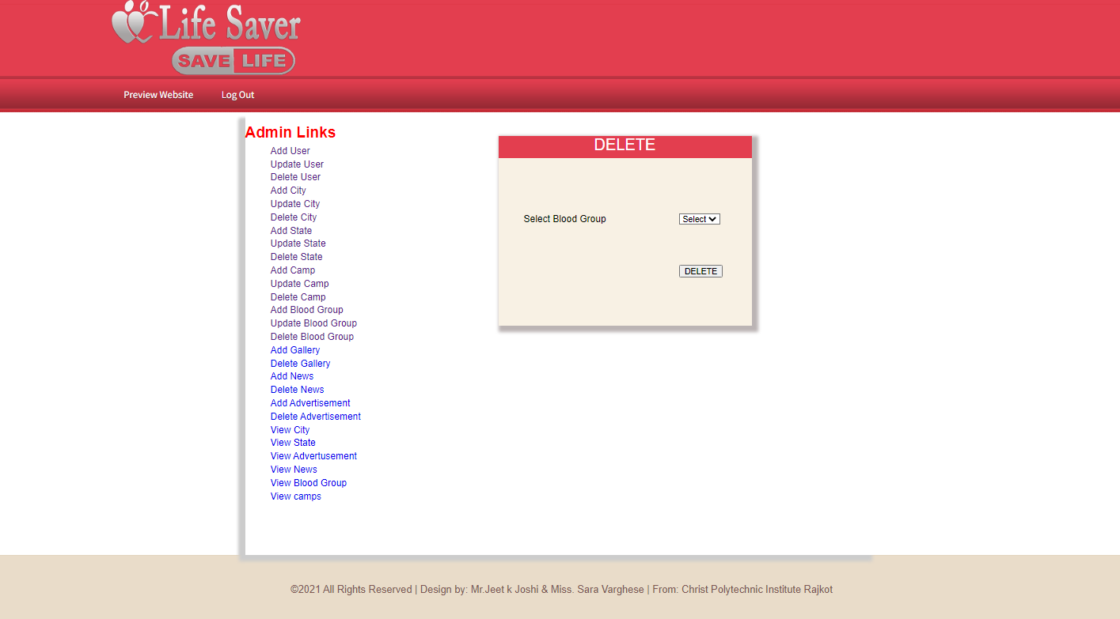

**Delete Blood Group**

With help of this hyper link we can delete the existing blood group.

**6.27 Add Gallery**

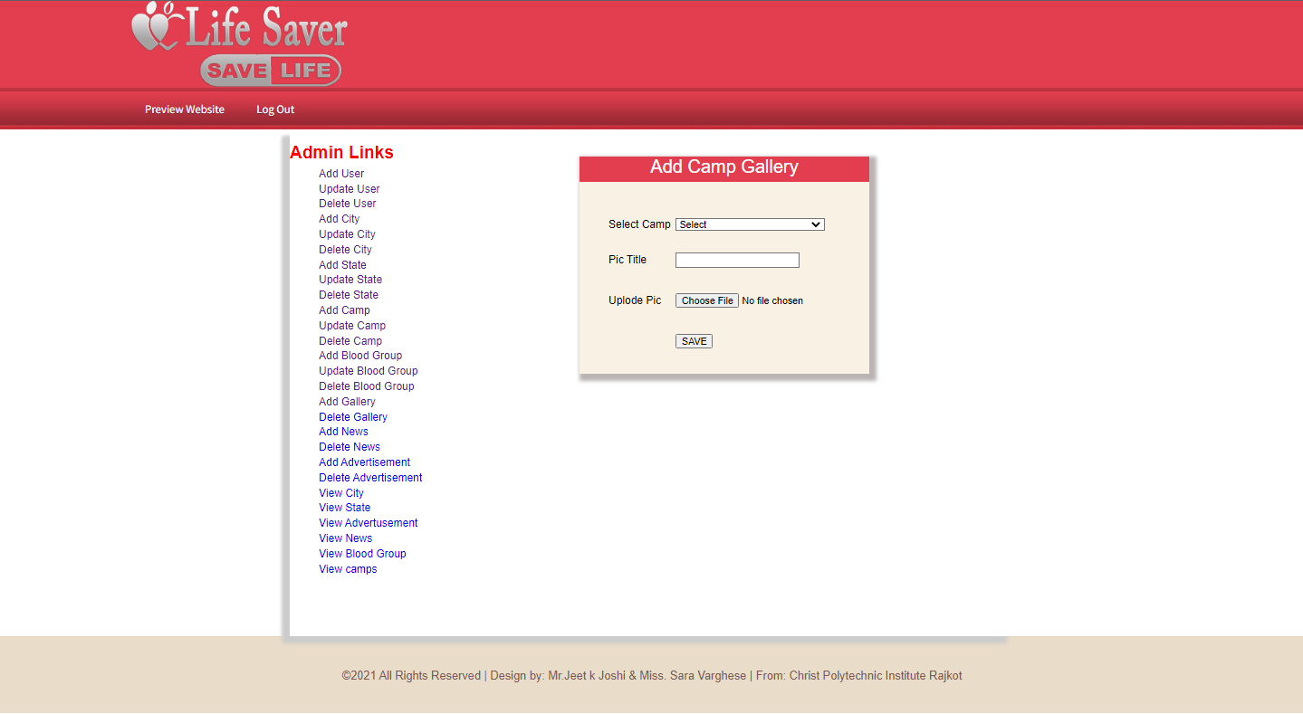

**Add Gallery**

A new gallery will be added to the database for those photos where we aren’t active.

**6.28 Delete Gallery**

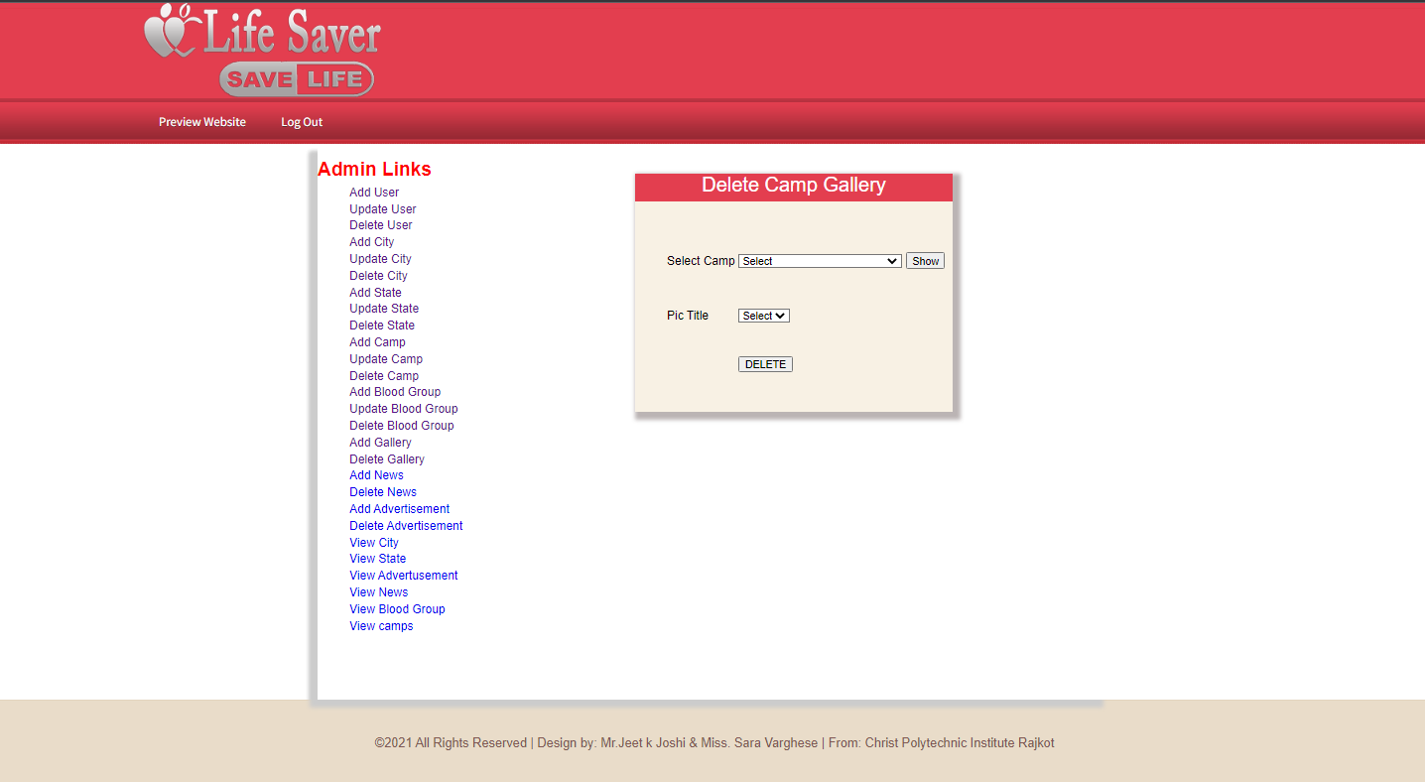

**Delete Gallery**

With help of this hyper link we can delete the existing gallery.

**6.29 Add News**

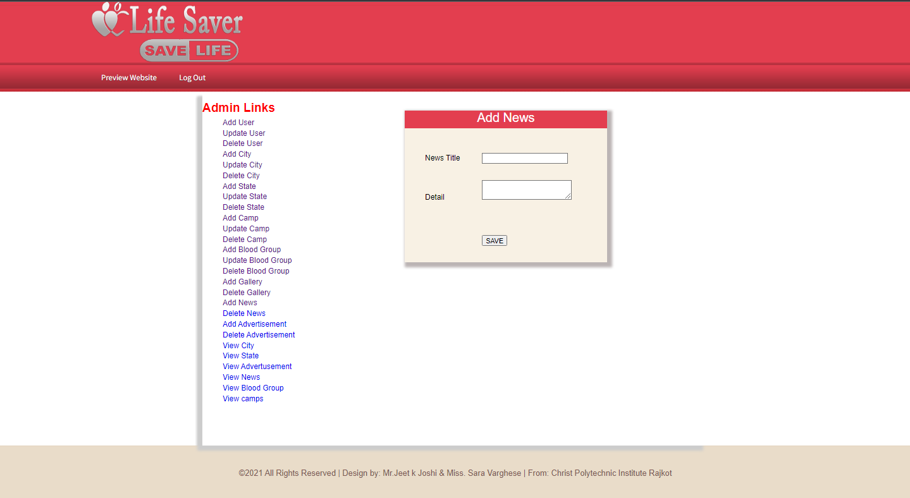

**Add News**

A new news will be added to the database for those news where we aren’t active.

**6.30 Delete News**

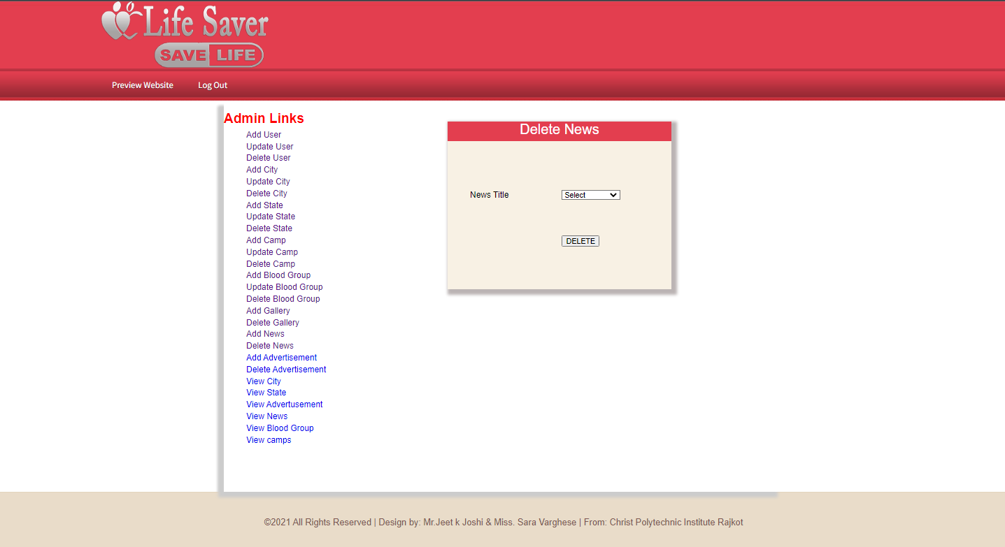

**Delete News**

With help of this hyper link we can delete the existing news.

**6.31 Add Advertisement**

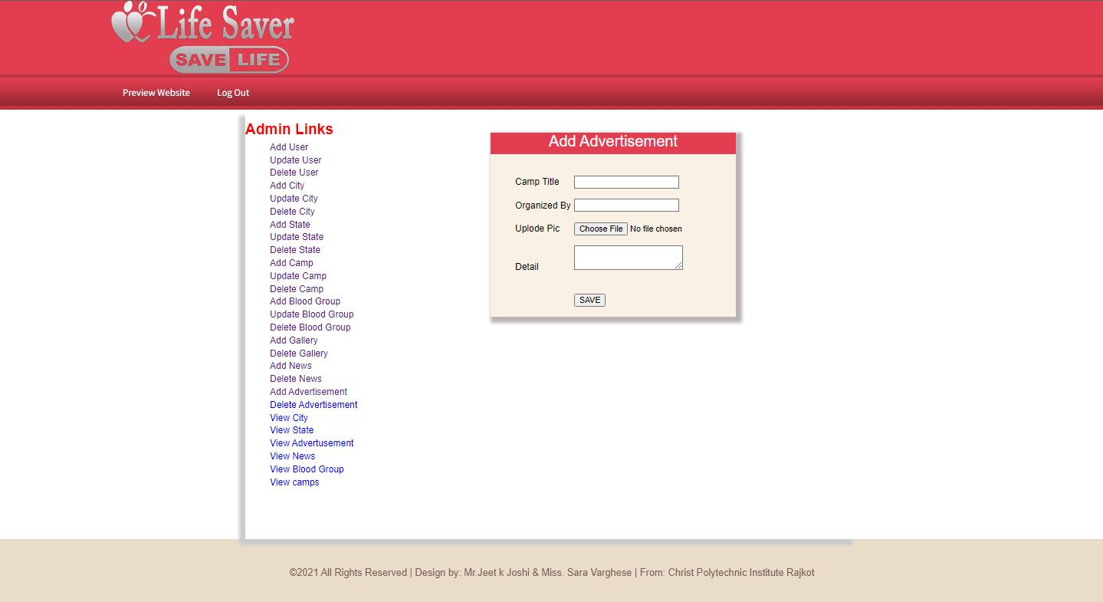

**Add Advertisement**

A new advertisement will be added to the database for those adds where we aren’t active.

**6.32 Delete Advertisement**

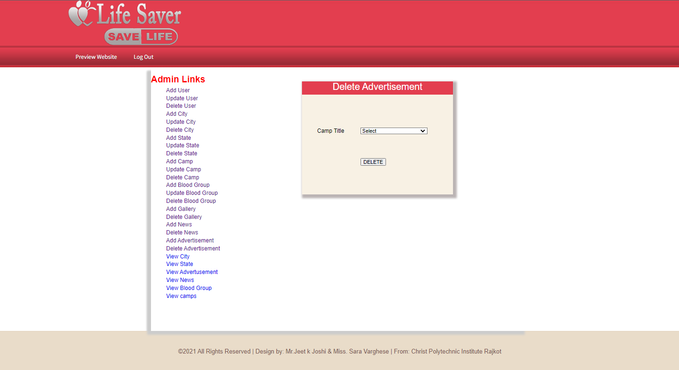

**Delete Advertisement**

With help of this hyper link we can delete the existing advertisement.

**6.33 View City**

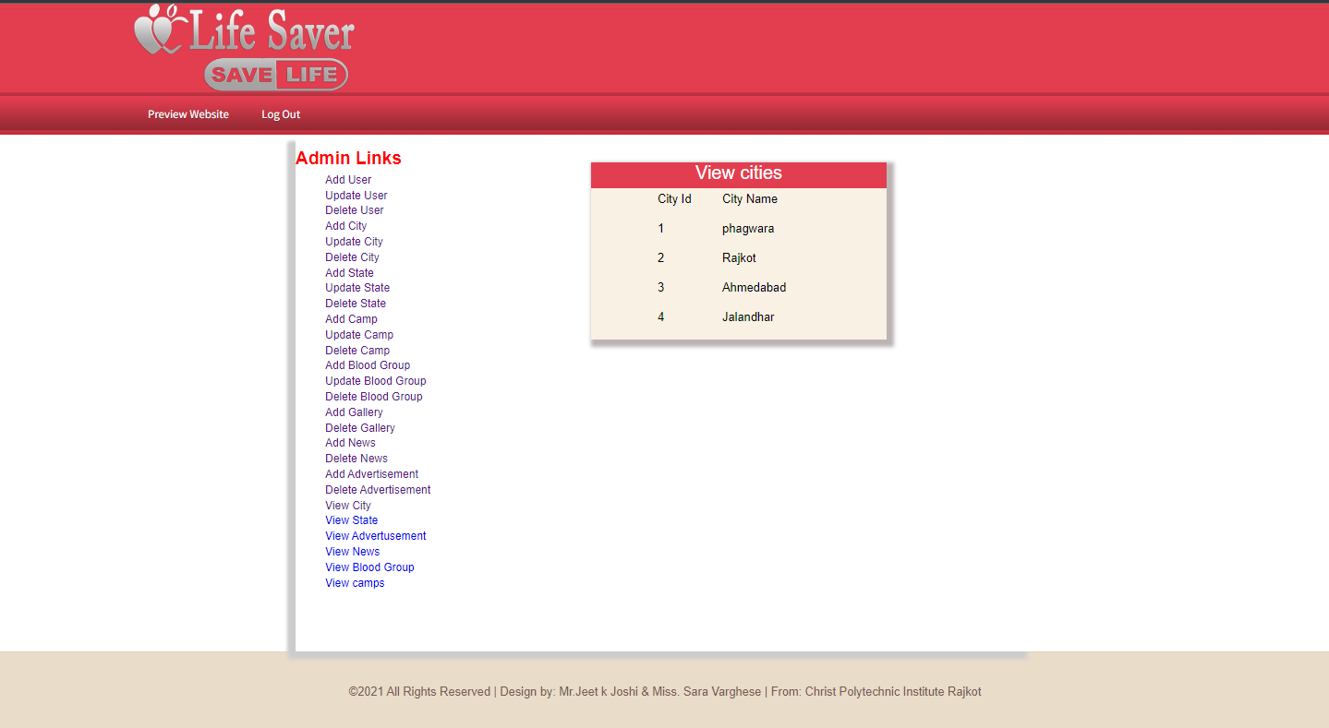

**View City**

A new city will be viewed to the database for those cities where we aren’t active.

**6.34 View State**

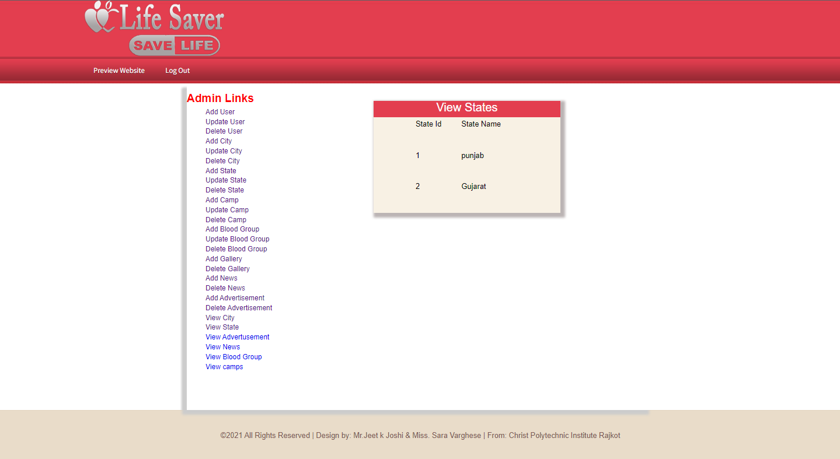

**View State**

A new state will be viewed to the database for those states where we aren’t active.

**6.35 View Advertisement**

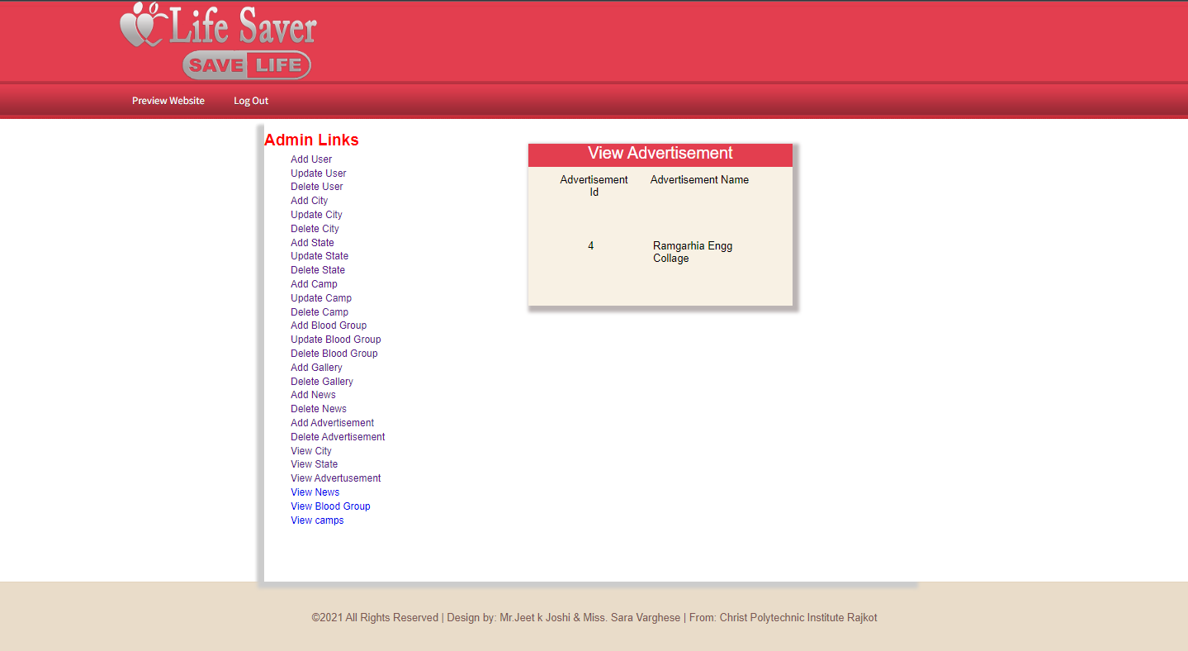

**View Advertisement**

A new advertisement will be viewed to the database for those adds where we aren’t active.

**6.36 View News**

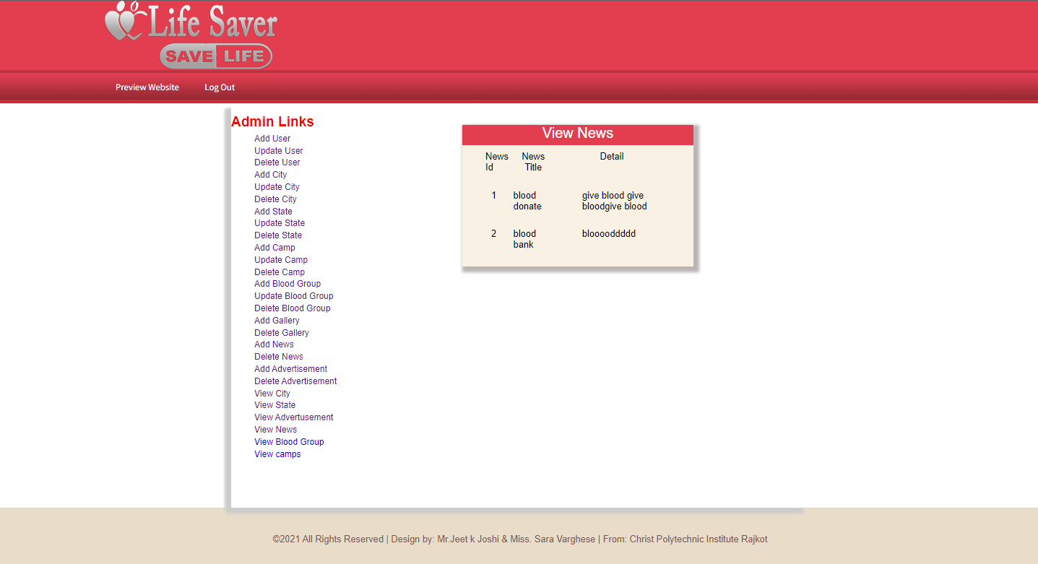

**View News**

A new news will be viewed to the database for those news where we aren’t active.

**6.37 View Blood Group**

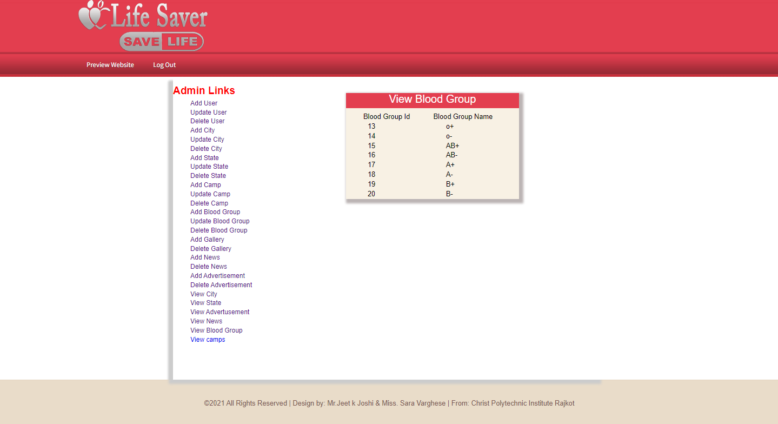

**View Blood Group**

A new blood group will be viewed to the database for those group where we aren’t active.

**6.38 View Camp**

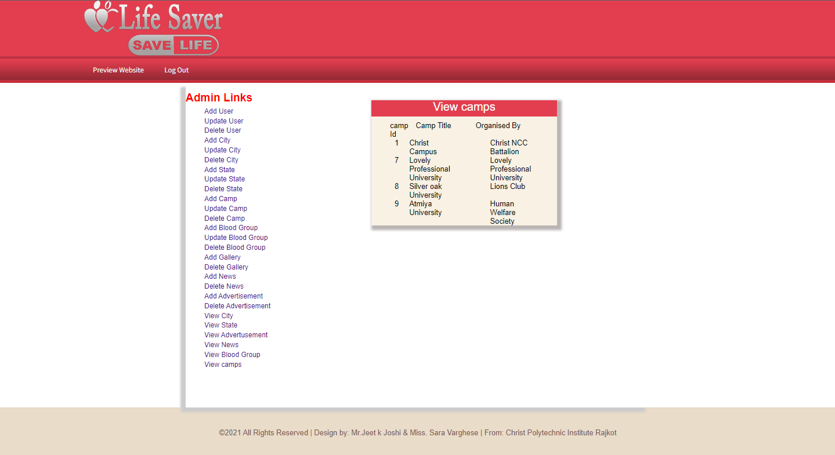

**View Camps**

A new camp will be viewed to the database for those camps where we aren’t active.

**6.39 Donor Panel**

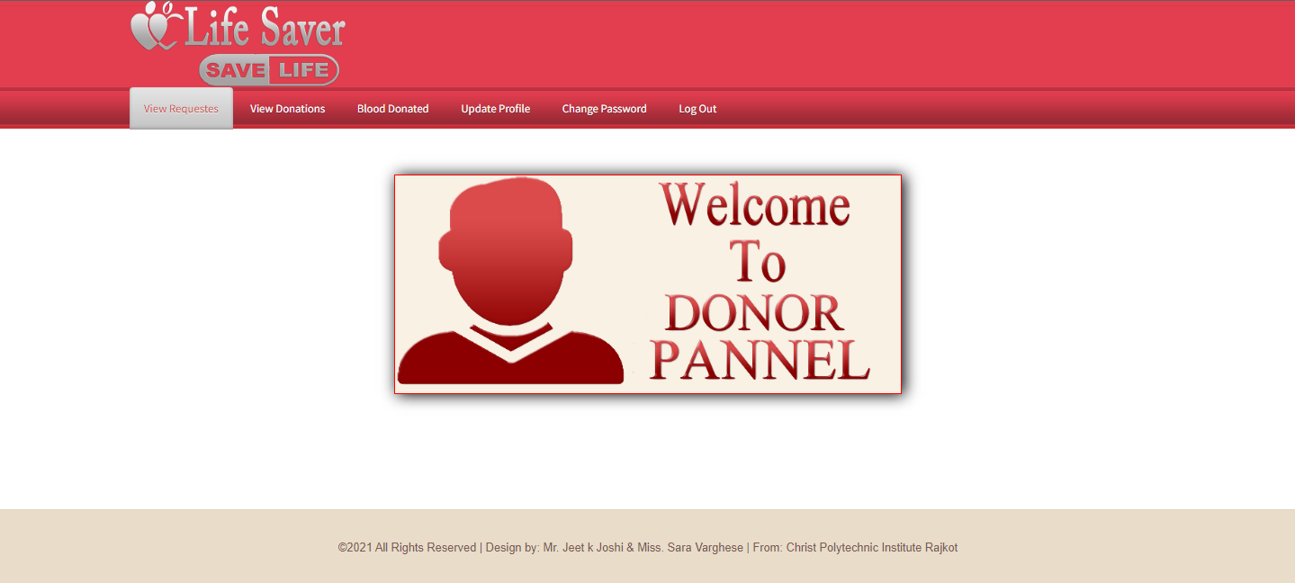

**Donor panel**

Using donor panel we can use email and password for Login in the Donor panel

**6.40 View Donation**

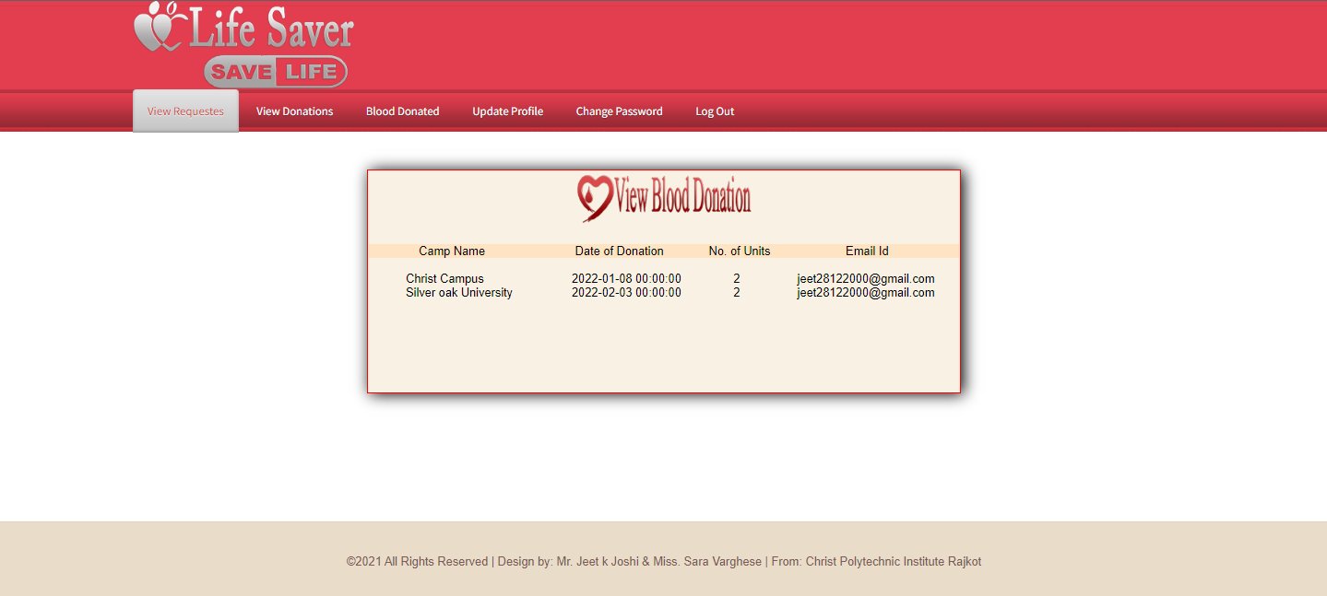

**View donation**

Donor can view the donation in this section

**6.41 Blood Donation**

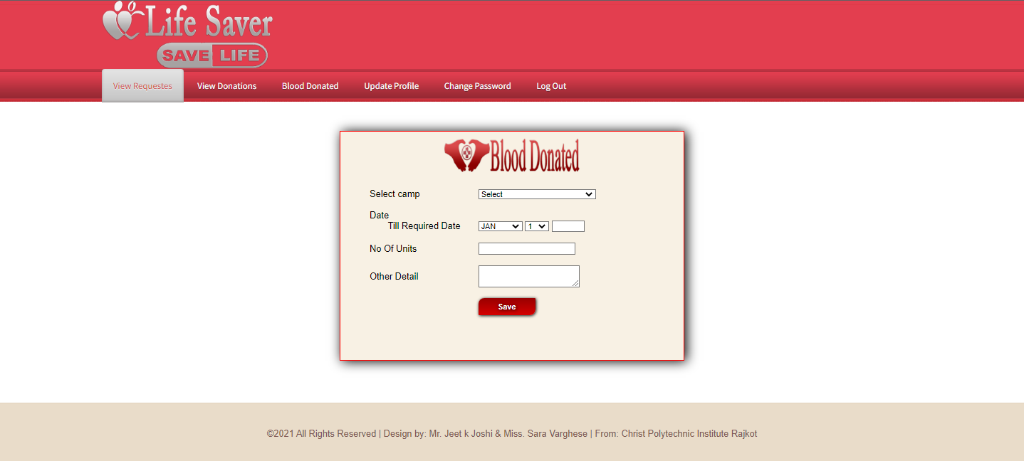

**Blood Donation**

Donor can donated the blood using this section

**6.42 Update Profile**

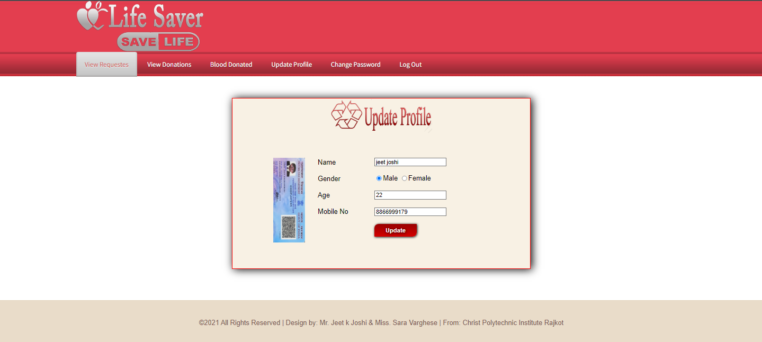

**Update Profile**

Donor can update the profile by using this section.

**6.43 Change Password**

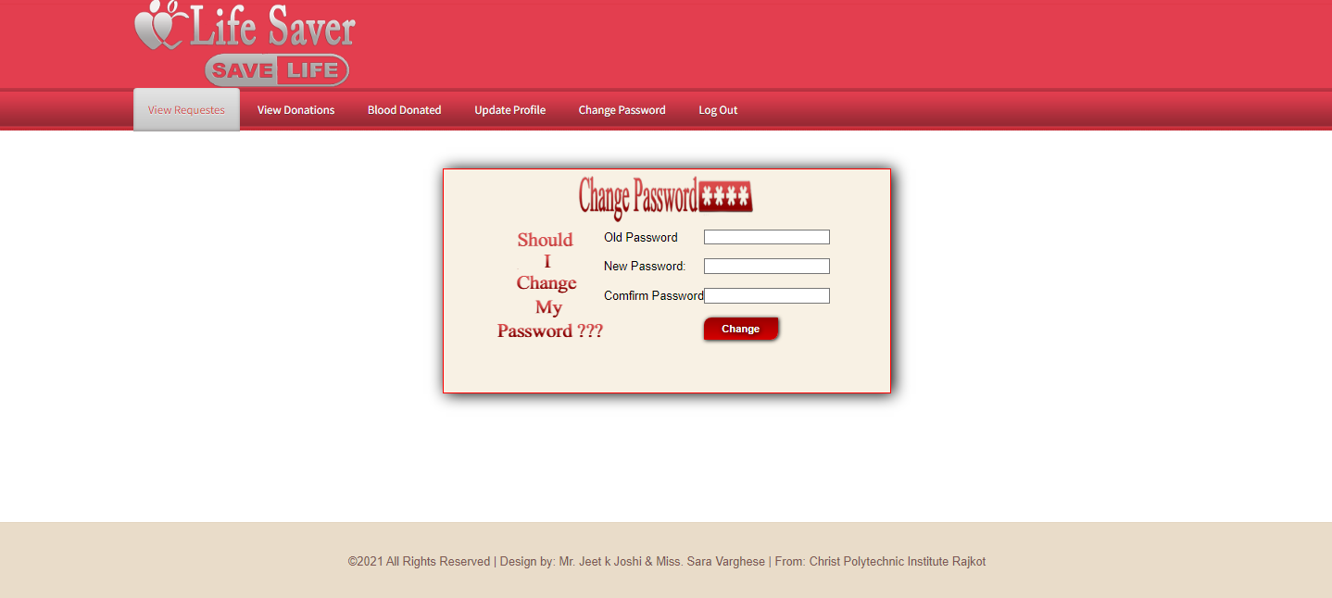

**Change Password**

Donor reset the password by using this section

**CHAPTER-7**

Pros

**7.0 Pros**

It provides the unique identification number at the time of blood donation camp helps him for the future correspondence. MIS gives a unique user id and password for those donors who are applying online. They can edit their information from time to time.

**CHAPTER-8**

Limitation & future enhancement

**8.0 Limitation & future enhancement**

**8.1 Limitation**

Here we are not considering that our project is so perfect but also some limitation or need for future enhancement are there which are also ignorable for user. We have kept fully attention towards as this project put there is necessary to know about the limitation of this project. The system cannot work under DOS based environment. We have to install it on a standalone PC to use it on that particular PC.

**8.2- Future enhancement**

In future we can develop the website and add more features as much as possible. We will make the system to work in larger system.

**CHAPTER-9**

Bibliography

**Bibliography**

Here we make this system by take reference form many websites and applications. Websites:

* [www.eraktkosh.in](http://www.eraktkosh.in)
* [www.bloodbanktoday.com](http://www.bloodbanktoday.com)
* [www.w3school.com](http://www.w3school.com)
* [www.phptpoint.com](http://www.phptpoint.com)